EXAMFLOW: THE DEVELOPMENT OF A WEB-BASED SPECIAL EXAMINATION APPROVAL SYSTEM WITH AUTOMATED EMAIL NOTIFICATIONS AND PARENT/GUARDIAN FACE AND ID VERIFICATION FOR STI COLLEGE STA. MARIA

A Capstone Project Proposal
Presented to the Faculty of the
Information and Communications Technology Program
STI College Sta. Maria

In Partial Fulfillment
of the Requirements for the Degree
Bachelor of Science in Information Technology
Kurt V. Aquino
Justine C. Casano
R. James M. Delos Santos
John Jeffrey C. Socorin

MAY 2026
TABLE OF CONTENTS
 |  |  | Page
Title Page |  |  | i
Table of Contents |  |  | iv
Introduction
 | Project Context |  | 1
 | Purpose and Description |  | 6
 | Objectives |  | 7
 | Scope and Limitations |  | 9
Review of Related Literature/Studies/Systems
 | Related Literature |  | 11
 | Benchmarking |  | 13
 | Related Studies and/or Systems |  | 15
 | Synthesis |  | 17
Technical Background
Conceptual Model of the Study |  |  | 19
Technologies to be Used |  |  | 21
Calendar of Activities |  |  | 23
Resources |  |  | 24
Methodology  Agile Development |  |  | 28
Requirements Analysis |  |  | 31
Appendices
 | Appendix A. Resource Persons
 | Appendix B. Evidence
 | Appendix C. Consent Letter
 | Appendix D. Summary of Interview
 | Appendix C. Curriculum Vitae

INTRODUCTION
Project Context
In the modern academic landscape, special examinations provide a vital opportunity for students to demonstrate their learning when external factors prevent them from attending regular schedules. Recent research by Elkington, Chesterton, and Wood (2024) emphasizes that flexible assessment strategies are essential for fostering student engagement and ensuring that personal hardships do not become permanent barriers to academic success. These assessments serve as a necessary bridge for students to maintain their academic momentum despite facing health issues or other legitimate emergencies.
STI College Sta. Maria, located at the AAA Building in Poblacion, Santa Maria, Bulacan, is one of the institutions that offer a special examination process. The campus provides various programs including Information Technology, Business Management, and Senior High School strands. Furthermore, Within the ICT Department alone, it is estimated that 60 to 100 students apply for special examinations every semester, according to the Program Head of the ICT, Ma'am Lara Camille Vergara.
The current procedure at STI College Sta. Maria follows a manual and paper-based system that varies based on whether a student has a valid excuse. For unexcused absences, a student who misses a regular exam must visit the Registrar to obtain a Special Exam Form. The student fills out personal and academic details such as their name, student number, course, year level, subject, section, and the teacher's name. Both the student and their parent or guardian must sign the document. They are also required to submit a photocopy of the parent or guardian's valid ID containing three specimen signatures to the registrar. The student then physically locates their subject teachers and the Program Head to collect signatures. Once all signatures are secured, the student proceeds to the Cashier to pay the 200 pesos fee per subject.
The student attaches the invoice to the form as proof of payment and returns to the Program Head's office to get the final signature. Finally, the student must wait for the exam schedule to be posted on the bulletin board, which requires them to physically visit the campus.
The process changes slightly for students with valid excuses, such as a medical or death certificate. The initial steps remain identical regarding obtaining the form and securing the teacher's signature. However, when the student proceeds to the Program Head, they present their valid certificate. The Program Head attaches the certificate to the form to validate the excuse. Because of this validation, the student is exempted from paying the 200 peso fee at the cashier and simply waits for the special exam schedule.
To evaluate this current workflow, researchers gathered data through surveys and interviews from Program head, students, subject teachers, registrar, and parents. A total population sampling method was applied to the department heads using a five-question survey. Sir Rome Olimpia, the General Education Department Head, opted out because he was unfamiliar with the process. The remaining program heads participated in the survey. Sir Allan Badilla Jr. from Business Management stated that an integrated system with online submission, document uploads, automated notifications, and real-time tracking is crucial for efficiency. Ma'am Mary Grace Pangilinan from Senior High School highlighted the need for schedule notifications and organized student lists. Ma'am Lara Camille Vergara from Information and Communications Technology emphasized the necessity of automated collection and verification to eliminate manual encoding. Furthermore, purposive sampling was used to interview forty students who had previously taken a special exam. While the total population of such students is unknown, these forty respondents provided a strong baseline. Data gathering for subject teachers is currently ongoing.
For the student demographic, purposive sampling was utilized because the exact total population of students taking special examinations is currently unknown. Out of the 82 students surveyed, a significant majority of 61 respondents stated that they would definitely prefer the new automated system.
Meanwhile, 15 students answered "maybe," four preferred the current manual process, and two remained unsure. For the Program Heads, total population sampling is being employed. While data gathering is still ongoing, initial responses from nine subject teachers indicate a strong lean toward automation. When asked if they would prefer a digital system that allows them to review and approve a student's requirements with a single click thereby eliminating physical forms and manual signatures, seven teachers answered "yes," while only two preferred the traditional method. Finally, purposive sampling was also used to assess the readiness of the students' parents or guardians. The survey asked if they were comfortable taking a selfie and capturing a valid ID for digital verification instead of submitting a physical photocopy. Out of 35 initial respondents, 21 agreed to the digital alternative, ten remained neutral, and only four disagreed. While data collection for both teachers and parents continues, these preliminary findings provide a strong, data-driven justification for the development and implementation of the EXAMFLOW system.
The primary issue with the current setup is its heavy reliance on physical paper routing. This outdated approach lacks remote accessibility, causing workflow Inefficiencies for faculty and unnecessary delays for students. Specifically, recording exam lists is highly inefficient because program heads manage separate personal files that are only consolidated near deadlines. Securing physical signatures is another major bottleneck. Half of the surveyed students identified finding teachers for signatures as the most difficult part of the process, and absent teachers cause severe delays Additionally, students struggle with communication because they lack a reliable remote method to check exam schedules. Finally, the paper-based system is highly vulnerable to fraud. The process relies entirely on photocopied IDs and physical signatures, which students can easily forge without real-time verification (Kumar & Sharma, 2025).
While various digital solutions exist for managing administrative workflows, none fully address the specific combination of security and academic management required for the special examination process. General platforms like Jotform and Sprout Solutions support digital form collection and approval routing but lack built-in biometric verification, leaving institutions vulnerable to fraudulent parent approvals. Specialized identity verification systems like iDenfy offer liveness detection but do not provide integrated academic routing, status tracking, or automated Excel reporting.
Even Philippine-focused platforms like Edusuite do not combine real-time biometric scanning with automated email notifications tailored for a specific institution. This creates a significant research gap, as no existing unified web-based platform merges high-security biometric liveness detection with a complete academic approval workflow and automated reporting engine. This study addresses this gap by developing EXAMFLOW.
General Problem
The main problem of the study is that the Special Exam process is currently managed through physical paper-based signature collection, lacking a centralized digital framework for students and faculty to process approvals or view notifications remotely. This manual system results in workflow disruptions for teachers and significant delays for students.

Specific Problems
- Manual Data Entry for Special Exam Records.
The recording of the special exam list is currently a manual process using Excel spreadsheets. According to an interview with ICT Program Head Lara Camille Vergara, different program heads record the forms they receive on their own individual files. These separate records are only merged into a centralized Excel file on OneDrive when the deadline is almost reached. Because the recording is done manually, it wastes a lot of time for the coordinators and leads to a disorganized and slow workflow.
- Delays for Students in Securing Physical Signatures.
The special exam process heavily depends on students physically locating their subject teachers and program heads to obtain the required signatures. If a teacher is absent, the student is unable to proceed with their request, causing significant delays.
- Inefficiencies to Faculty Workflow Due to Manual Signing.
The current physical process is Inefficient for the faculty. Subject teachers must frequently pause their ongoing work, such as checking papers or preparing lessons, to accommodate students who need manual signatures on physical special exam forms.
- Lack of Communication and Notification of Exam Schedules.
Students lack a reliable way to check their special exam schedules remotely and must repeatedly travel to the school or check physical bulletin boards for updates.

- Lack of Parent Verification.
The registrar's office currently has no way to verify if a student's parents are truly involved in the special exam request. The process relies on a photocopied ID and three physical signatures, which can be easily faked by students. This was directly observed by ICT Program Head Ma'am Lara Camille Vergara, who noted that there is a lack of parent verification in the current process, as some students have been faking their parent's signature on the forms. According to research, traditional manual methods that rely on paper registers and physical signatures are highly vulnerable to manipulation and "proxy" actions, where records are easily tampered with or signatures are forged without real-time oversight (Kumar & Sharma, 2025).

Purpose and Description
The purpose of this project is to develop EXAMFLOW, a web-based special exam management system for STI College Sta. Maria that streamlines student requests, faculty approvals, and schedule monitoring. The system consolidates all special exam records in one platform, providing students and faculty with an accurate, organized, and remote way to process and track special examinations.
Key features include a centralized digital dashboard that provides program heads with a live list of accepted students and easily exports data into the school's official Excel template. It also features a digital submission and tracking system so students can monitor their request status remotely, an online approval module that allows subject teachers and program heads to accept or reject forms without interrupting their classes, and an automated notification system that sends schedule updates directly to the students' email accounts. Additionally, a Liveness Detection feature requires parents to take a live selfie with their physical ID, ensuring secure parent verification.
This project is unique and innovative because it combines remote approval workflows, centralized record-keeping, automated email notifications, and liveness detection, providing a highly secure and modern approach to special exam management.

General Objective
The main objective of this study is to develop EXAMFLOW, a web-based special exam management system designed to digitize manual record-keeping and reduce the manual collection of physical signatures for both students and faculty. This platform serves as a centralized digital gateway that transforms the traditionally slow, paper-based routing into an Immediate and verifiable electronic process.

Specific Objectives
- To be able to develop an automated Excel exporting.
The dashboard will provide a real time of accepted students that updates automatically when a form is submitted through the app. All program heads can view this centralized list, and they can easily export the final data into an Excel file that perfectly matches the school's current template.
- To be able to develop a digital submission and status tracking system.
Students will be able to fill out their forms and submit requirements directly through the app. They can track the real-time status of their request from "submitted" to "accepted" without needing to physically walk around the campus to locate their subject teachers or program heads.
- To be able to develop an online approval module for the faculty.
Subject teachers and program heads can review special exam requests directly through the app and accept or reject them at their convenience by simply clicking a button.

- To be able to develop an automated email notification system using Microsoft Outlook.
Instead of students repeatedly traveling to the school or checking physical bulletin boards, the system will automatically send schedule updates and notifications directly to the students' Microsoft Outlook email accounts.
- To be able to develop a Liveness Detection feature for parent verification.
To authorize the exam, parents will be required to take a live selfie while followed by the valid id. While the system does not check a government database, the liveness detection ensures that a real person is physically present during the process, preventing students from using static photos or digital copies to bypass the requirement. According to research, liveness detection is a highly effective defense against "presentation attacks," where individuals try to use unauthorized or fake media to impersonate others in manual or semi-automated verification processes (Smith & Jones, 2025).

Scope
Student
- Remotely submit all requirements for special examinations.
- Monitor the live status of their application from "Submitted" to "Accepted."
- Utilize a Liveness Detection module that requires a live selfie and valid ID upload to secure remote parental consent.
- Receive direct updates regarding exam schedules via Microsoft Outlook.
Program Head
- Review, accept, or reject student applications digitally
- Access a centralized, real-time list of all accepted students.
- Download final student data directly into the exact Excel template used by the school.
- Set and manage the allowable timeframe (number of days) for students to submit their forms.
Subject Teacher
- Digitally review and approve student requests.
Registrar
- Digitally review and verify the authenticity of the documents and forms uploaded by the students.
Administrator
- Add, update, or remove user accounts (students, faculty, and staff) within the web application.
- Manage the academic database by inputting subjects and assigning the respective subject teachers to the system.
Limitations
- The system is developed exclusively as a web-based platform to prioritize a centralized administrative workflow, meaning it does not currently offer native mobile applications for Android or iOS.
- Technical constraints within the biometric module mean that face detection accuracy may be significantly reduced if a parent or guardian has facial tattoos that obscure key facial landmarks.
- While the system uses liveness detection, it cannot independently verify the biological identity of the parent, meaning it cannot stop a student from intentionally asking another person to pose as their guardian during the digital check.
- Students must still obtain and process a physical form from the Registrar because STI institutional standards require physical documentation for official record-keeping and formality.
- Financial transactions are not processed within the app because the Cashier operates on an independent, pre-existing system; therefore, EXAMFLOW is limited to handling receipt images for manual verification.
- The system cannot electronically verify the authenticity of uploaded Government IDs due to the lack of authorized integration with official, external government databases.

REVIEW OF RELATED LITERATURE/STUDIES/SYSTEMS
Review of Related Literature
Automated Excel Exporting
Automated data entry and exporting using platforms like Excel reduces the time spent on manual transcription and drastically lowers the chance of human error. Moving from manual data encoding to automated systems allows educational institutions to accurately capture, organize, and evaluate large volumes of administrative data with minimal effort. This technology actively addresses inefficiencies in traditional record keeping by instantly transforming submitted data into structured spreadsheets ready for analysis (Kudra, 2024).
Status Tracking System
A status tracking system provides real-time visibility into the progress of submitted documents or requests. For academic processes, implementing a tracking module eliminates the uncertainty and anxiety students often face while waiting for administrative approvals. Research indicates that clear visual tracking dashboards help identify bottlenecks and ensure that requests follow their designated paths without unnecessary delays (Larksuite, 2025).
Online Approval Module
An online approval module facilitates digital review and sign-offs, completely replacing the need for physical document routing. This digital framework allows faculty members to review and approve student requests remotely, which ensures that academic workflows continue without disruption even when key personnel are off-campus. Adopting automated approval workflows significantly reduces processing times and builds a reliable digital audit trail for institutional records (Rogers Capital, 2024).

Automated Email Notification System
Integrating automated email notifications via standard platforms ensures instant communication between the system and its users. Automated alerts actively inform approvers when a new request is pending and immediately notify students when their submission is approved or rejected. This automated nudge system eliminates the need for manual follow-ups and keeps the entire decision-making process moving smoothly from start to finish (Larksuite, 2025).
Liveness Detection
Liveness detection is an advanced biometric security measure that verifies whether the person interacting with the system is physically present and alive. In remote educational processes, this feature prevents impersonation and spoofing by requiring users to take a real-time selfie or perform a simple action. Implementing liveness detection provides strong identity verification for parental consent, effectively stopping students from submitting forged documents or using static images to bypass security (iDenfy, 2024)

Benchmarking
Features | ServiceNow | Jotform | iDenfy | Sprout Solutions | Edusuite | EXAMFLOW: The development of a web-based special examination approval system with automated microsoft outlook notifications and biometric liveness detection for STI College sta. maria
- Automated Excel Exporting | ✔ | ✔ |  | ✔ |  | ✔
- Status Tracking System | ✔ | ✔ |  | ✔ | ✔ | ✔
- Online Approval Module | ✔ | ✔ |  | ✔ | ✔ | ✔
- Automated Email Notification | ✔ |  |  |  |  | ✔
- Liveness Detection |  |  | ✔ |  |  | ✔
Table 1.0 Benchmarking Table
The benchmarking table demonstrates that several administrative features are established industry standards across existing platforms. A Status Tracking System and an Online Approval Module are almost universally present in workflow and management systems such as ServiceNow, Jotform, Sprout Solutions, and Edusuite. These modules provide transparency by allowing users to monitor their submissions while enabling administrators to efficiently authorize or reject requests digitally. Additionally, Automated Excel Exporting is frequently available in platforms like ServiceNow, Jotform, and Sprout Solutions to aid in data consolidation and reporting. These common features are significant because they reduce the need for manual follow-ups and ensure that administrative documents are processed in a structured and timely manner.
However, highly specialized technological capabilities remain rare among the systems reviewed. Automated Email Notification is a distinct feature found primarily in enterprise IT platforms like ServiceNow, ensuring that stakeholders are instantly updated directly within the Microsoft ecosystem without manual intervention. Furthermore, Biometric Liveness Detection is a highly specialized security measure appearing exclusively in dedicated identity verification platforms like iDenfy. Its purpose is to prevent identity fraud by ensuring the physical presence of a human user during remote submissions. While most general systems handle basic data management well, they lack this strict anti-fraud verification.
The proposed system, EXAMFLOW, addresses these exact technological gaps by integrating all five features into a single, cohesive platform tailored specifically for academic exam management at STI College Sta. Maria. It combines the tracking, approval, and automated exporting workflows of traditional form builders with the advanced biometric liveness detection typically reserved for high-end security software. By also including a dedicated automated Email notification engine, EXAMFLOW provides a more comprehensive, localized, and secure solution for the special examination process than any of the individual commercial systems reviewed.

Related Studies and/or Systems
ServiceNow
ServiceNow is a cloud-based IT service management platform used by global enterprises to route internal requests, digitize workflows, and manage organizational operations. The platform includes a Status Tracking System that allows employees to monitor the progress of their submitted tickets in real-time. It features an Online Approval Module where managers can authorize or reject requests. Additionally, it supports Automated Excel Exporting for reporting purposes and features native Automated Email Notifications via its Actionable Messages integration, allowing users to interact directly within their Outlook client.
Jotform
Jotform is a web-based form-building platform that allows organizations to create custom data collection pipelines and digital workflows. It features an Online Approval Module where administrators can build sequential approval flows for form submissions. The system includes a Status Tracking System via its Inbox and Tables dashboards, enabling users to see where their submission is in the pipeline. It also supports Automated Excel Exporting, allowing administrators to push collected form data directly into downloadable spreadsheet formats.
iDenfy
iDenfy is a remote identity verification and fraud prevention platform utilized by financial and educational institutions to authenticate users during digital onboarding. The system integrates advanced Biometric Liveness Detection, which requires the user to perform active movements (such as blinking or turning their head) to ensure they are a physically present human, preventing the use of static images or spoofed videos during the submission process.

Sprout Solutions
Sprout Solutions is a Philippine-based human resources and payroll management system designed specifically to handle local corporate compliance and employee requests. The platform features an Online Approval Module utilized by department heads to review and authorize employee filings, such as leaves or schedule adjustments. It provides a Status Tracking System for employees to monitor the standing of their submissions and includes Automated Excel Exporting to generate localized HR and payroll reports.
Edusuite
Edusuite is a locally developed, AI-driven school management system utilized by various educational institutions across the Philippines to streamline enrollment and academic records. The platform features an Online Approval Module that allows school administrators and registrars to process and authorize student clearances and document requests. It also contains a Status Tracking System integrated into the student portal, allowing learners to check the real-time progress of their academic submissions.

Synthesis
The related systems reviewed demonstrate that existing administrative and digital form platforms have made significant progress in streamlining data collection and workflow management. General enterprise and local HR platforms, such as Jotform and Sprout Solutions, illustrate how integrating online approval modules and automated Excel exporting can significantly reduce administrative workloads and minimize manual data entry. Furthermore, specialized school management systems like Edusuite highlight the importance of status tracking systems to monitor the progress of student documents remotely. Enterprise IT platforms like ServiceNow showcase the efficiency of automated Email notifications to keep stakeholders instantly informed. Finally, high-security platforms like iDenfy emphasize the growing necessity of advanced biometric tools, specifically liveness detection, to verify the physical presence and true identity of users in a digital environment.
However, despite these technological advancements, the reviewed systems exhibit noticeable gaps when applied to the specific academic procedures of a local institution. General data collection and HR systems, while robust in form building and tracking, lack the specialized biometric identity verification required to prevent student fraud. Conversely, standalone security platforms like iDenfy are missing comprehensive academic workflow tools and localized data exporting capabilities. Most notably, local educational platforms like Edusuite do not possess deep integrations for automated Email notifications or advanced liveness detection. This gap is critical for institutions like STI College Sta. Maria, where the current special examination process still relies on manual signature routing, fragmented Excel files, and easily forged photocopied parent IDs. These specific vulnerabilities are not fully addressed by any single commercial system currently available.
These gaps establish the necessity for a more comprehensive and tailored solution. EXAMFLOW addresses this need by consolidating all five critical features into a single platform engineered specifically for the local academic environment.

It combines automated Excel exporting, a real-time status tracking system, and an online approval module with specialized automated Microsoft Outlook notifications and biometric liveness detection for strict parent/guardian verification. Unlike general corporate tools built for broad business functions, or standalone security applications that lack workflow management, EXAMFLOW is designed to serve both students and faculty. By reducing physical document routing, centralizing notifications within the school's preferred email ecosystem, and securing the approval chain against identity fraud, the proposed system provides a necessary, practical, and highly secure contribution to solving the administrative bottlenecks of the special examination process.

TECHNICAL BACKGROUND
Conceptual Model of the Study
INPUT
Knowledge gathering
• Data gathering through interviews and surveys at STI College Sta. Maria
• Review of Related Literature and Studies (RRL)
Requirements
• Visual Studio Code
• Microsoft Teams, Facebook Messenger
• Microsoft Word
• Google Chrome
• GitHub
• HTML5, Tailwind CSS, TypeScript
• React, Next.js
• Supabase (PostgreSQL)
• Vercel
Hardware Requirements
(Desktop / Laptop)
• OS: Windows 10/11
• RAM: 4 GB or higher
• Storage: 128 GB HDD or SSD
• CPU: Intel Core i3 or AMD Ryzen 3
• Monitor: 1366 x 768 resolution, 60Hz

OUTPUT
EXAMFLOW: The Development of a Web-Based Special Examination Approval System with Automated Email Notifications and Parents Liveness Detection for STI College Sta. Maria
PROCESS
• Requirements
• Design
• Development
• Test
• Deployment
• Review

EVALUATION

Figure 1.0 Input-Process-Output (IPO) Framework
The Conceptual Model of this study is framed by the Input-Process-Output Framework, illustrating the systematic plan for developing EXAMFLOW: The Development of a Web-Based Special Examination Approval System with Automated Email Notifications and Parents Liveness Detection for STI College Sta. Maria. For the Input phase, foundational knowledge is gathered through interviews and surveys conducted at STI College Sta. Maria to understand the current special examination procedures. This is supported by a comprehensive Review of Related Literature and Studies. The software requirements needed to build and coordinate the system include Visual Studio Code, Microsoft Teams, Facebook Messenger, Microsoft Word, Google Chrome, and GitHub. The core development technologies consist of HTML5, Tailwind CSS, TypeScript, React, Next.js, Supabase (PostgreSQL), and Vercel. The Hardware Requirements are divided into two categories. For desktop or laptop development, the system requires a device running Windows 10 or 11, equipped with an Intel Core i3 or AMD Ryzen 3 processor, 4 GB or higher of RAM, at least 500 MB of free storage space, and a monitor with a 1366 x 768 resolution at 60Hz. For mobile access, the system requires a device running Android 9.0 or iOS 15 and higher, with 2 GB or higher of RAM, at least 200 MB of free storage space, a quad-core 1.8 GHz or higher processor, and a 5-inch display with a 720 x 1280 resolution. The Process phase outlines the development lifecycle, which includes the stages of Requirements, Design, Development, Test, Deployment, and Review to ensure the system is functional and accurate. The Output is the finalized EXAMFLOW system designed to streamline the approval and notification process for special exams. The final Evaluation phase will assess the completed system to ensure it meets the project objectives and effectively serves the needs of STI College Sta. Maria.

Technologies to be Used
Web-based technologies are used by the developers to create, manage, and run the EXAMFLOW system so it can be accessed through the internet using a web browser. These technologies allow students and faculty to interact with the system from any device without needing to install specialized software. For the frontend, the developers utilize HTML5, Tailwind CSS, and TypeScript with React to build the user interface. HTML5 provides the basic structure of the pages, while Tailwind CSS (v4) is used to create a clean and professional design through its utility-first classes, ensuring the dashboard is responsive across different screen sizes. TypeScript is used to add type-safe dynamic interactivity to the forms, and React serves as the component-based library that allows the developers to build reusable interface elements efficiently. On the backend, the developers use Next.js with TypeScript to manage the server-side logic and core application workflows, while SQL handles the database queries and schema within Supabase, a Backend-as-a-Service built on top of a PostgreSQL database. This backend infrastructure handles the processing of special exam requests, the routing of approvals between departments, and the overall coordination of the system's functions.
Database and Cloud Services are used to store, retrieve, and manage all critical information, such as student records, exam request statuses, and parent verification data. The developers utilize Supabase, which is a powerful Backend-as-a-Service (BaaS) built on top of a PostgreSQL database. Supabase provides the reliability and scalability needed to handle academic data while offering real-time capabilities that allow the system to update statuses instantly. Communication protocols such as HTTP and HTTPS are implemented to ensure that the data transmitted between the student’s browser and the server is encrypted and secure, protecting sensitive academic information from unauthorized access.

Automated Communication and Security technologies are integrated to enhance the efficiency and integrity of the system. To address the need for instant updates, an Automated Email Notification engine is used to alert students and faculty members immediately when a request is submitted, approved, or requires attention. This reduces manual follow-ups and ensures that the exam process stays on schedule. For identity verification, Liveness Detection technology is utilized during the parent or guardian verification phase. This specialized security feature requires the user to perform a real-time biometric scan, preventing the use of static photos or pre-recorded videos to bypass the approval process. These integrated technologies work together to ensure that EXAMFLOW is not only efficient but also highly secure and resistant to fraudulent submissions.

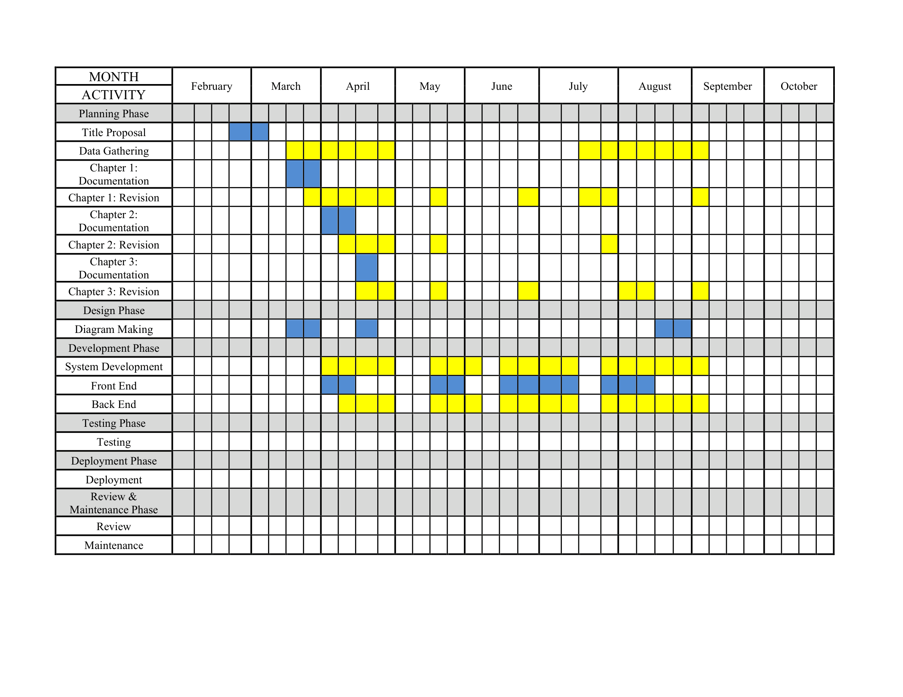
- Calendar of Activities
Table 2.0 Gantt Chart of Activities
- Resources
Hardware Requirements
Hardware Components | Hardware Specification
Operating System | Windows 10 or 11
Random Access Memory (RAM) | 4 GB or higher
Solid State Drive (SSD) | 128 GB HDD or SSD
Processor | Intel Core i3 or AMD Ryzen 3
Monitor | 1366 x 768 resolution, 60Hz
Table 3. Hardware Resources

Software Requirements
Software Categories | Specific Software
Integrated Development Environment | Visual Studio Code
Communication Tools | Microsoft Teams, Facebook Messenger
Word Processing Software | Microsoft Word
Internet Browsers | Google Chrome
Version Control | Github
Coding Languages | HTML and TypeScript
Frameworks & Libraries | React, Next.js, Tailwind CSS
Database | Supabase (PostgreSQL)
Deployment / Hosting | Vercel
Table 4. Software Resources
Visual Studio Code
The developers utilized Visual Studio Code as the primary Integrated Development Environment for the construction of EXAMFLOW. This Microsoft-developed editor was selected because it is highly efficient and offers a wide range of extensions that support the Laravel and Tailwind CSS environment. Its built-in features like syntax highlighting and IntelliSense allow the team to write cleaner code and identify potential errors early in the development process. Furthermore,
Communication Tools
Microsoft Teams and Facebook Messenger served as the main communication channels for the project team and their research adviser. These platforms enabled the developers to conduct virtual meetings, discuss technical requirements, and share progress updates in real time. Microsoft Teams was primarily used for formal consultations and file sharing, while Facebook Messenger allowed for quick coordination and immediate troubleshooting between team members.
Microsoft Word
Microsoft Word was used as the official word processing tool for the preparation of the capstone project documentation. It allowed the developers to organize the research findings and technical specifications into the required format for Chapter 1, Chapter 2, and Chapter 3. The software ensured that the manuscript adhered to the specific margin, font, and citation standards established by STI College Sta. Maria. This tool was essential for creating a professional and polished final proposal.
Google Chrome
Google Chrome was the primary web browser used for testing the functionality and responsiveness of EXAMFLOW. It provided a stable environment for the developers to view the system's interface and ensure that all features worked correctly across different resolutions. The browser's built-in developer tools were also used to inspect the code and debug the frontend layout during the building process. Additionally, it served as the main tool for conducting online research and gathering related studies for the project.
GitHub
GitHub was used as the version control platform for managing the source code of EXAMFLOW throughout the development process. It allowed the developers to store their code in a centralized repository, track changes, and collaborate simultaneously without overwriting each other's work. Through version history, the team could review previous versions of the code and revert changes when necessary.
Frontend Technologies
The user interface of EXAMFLOW was built using a combination of HTML5, Tailwind CSS, TypeScript, and React. HTML5 provides the fundamental structure of the web pages, while Tailwind CSS handles the design and layout through its modern utility-first approach. TypeScript adds type-safe interactivity to the system, reducing errors by enforcing consistent data types and making the forms and navigation elements more reliable. React serves as the component-based library that allows the developers to build reusable interface elements, making the frontend efficient and easier to maintain.
Next.js
Next.js was used as the primary framework to handle both the frontend rendering and the server-side logic of EXAMFLOW. Built on React and written in TypeScript, it manages the core application workflows, including URL routing, server-side rendering, and the processing of special exam requests through its API routes and server functions. This framework was chosen for its ability to simplify complex backend tasks while keeping the application organized, scalable, and easy to maintain, ensuring that the system remains secure when handling sensitive student records.
Supabase
Supabase was utilized as the backend-as-a-service provider to manage the system's database requirements. It provides a highly reliable environment for storing student information, exam request data, and verification records within its PostgreSQL database. Unlike traditional database setups, Supabase offers real-time data synchronization and built-in security features that protect the integrity of the information stored in the cloud.
Vercel
Vercel was used as the hosting and deployment platform for EXAMFLOW, making the system accessible online through a live web address. Developed by the same team behind Next.js, Vercel is optimized to run Next.js applications efficiently and integrates directly with GitHub for continuous deployment, automatically updating the live system whenever new code is pushed to the repository. This platform allowed the developers to deploy the system quickly and reliably without the need to manually configure a traditional web server.

METHODOLOGY
The developers will utilize the Agile Methodology for the development of EXAMFLOW: A web-based special examination approval system with automated microsoft outlook notifications and biometric liveness detection for STI College Sta. Maria. This iterative approach is selected because it allows the team to break down the complex requirements of the system—such as the liveness detection and the automated notification engine—into smaller, manageable cycles called sprints.
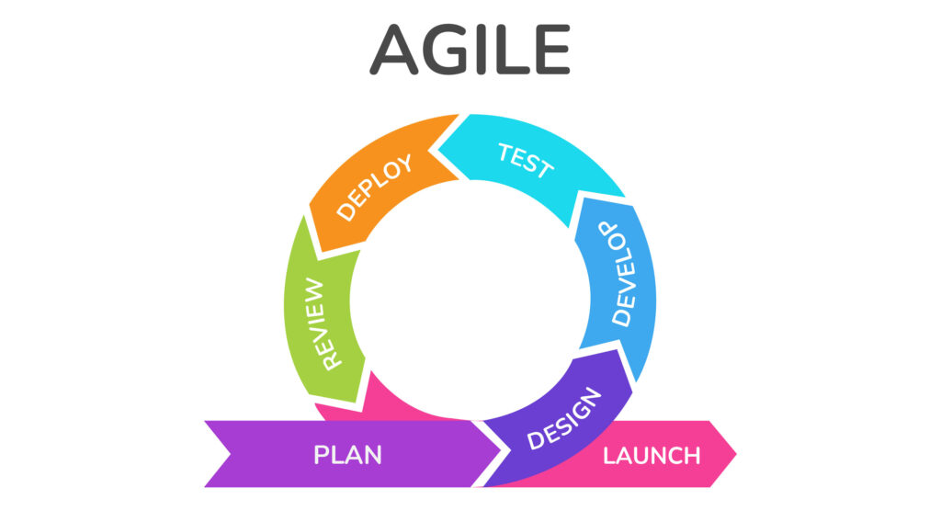
Planning
During the entire month of March and April 2026, the developers conducted extensive data gathering by interviewing the primary users of the system. These users included the students, program heads, subject teachers, registrar and the academic head of STI College Sta. Maria. The interviews focused on understanding the history of the special examination process and the specific challenges caused by their manual paper routing procedures. This data provided the foundation for proposing EXAMFLOW. Following the data collection, the developers focused on the manuscript and successfully finished the Chapter 1 and Chapter 2 documentation during the second week of April 2026.

Design
Following the comprehensive data gathering process, the developers will begin outlining the system by creating low-fidelity prototype sketches of the dashboard and form layouts. Using Visual Studio Code, the team will proceed with frontend development utilizing HTML5, Tailwind CSS, TypeScript, and React. They will create responsive user interface components such as status tracking bars, approval buttons, and notification panels. Google Chrome will be utilized to monitor and review these visual updates in real time. The team will also construct flowcharts and data flow diagrams to map out the specific processes of the system, including the automated email triggers and the liveness detection verification flow. The Chapter 3 documentation covering these system design specifications will be completed throughout the month of April and will be revised immediately afterward.
Development
Once the frontend interfaces are established, the developers will use Next.js with TypeScript to build the backend logic and connect the interactive elements of the system. Visual Studio Code will serve as the primary integrated development environment, while Google Chrome will be used for live browser testing. Next.js will run its own local development server during the initial coding phase, allowing the team to test the application before deploying it to a live platform. For data management, Supabase will be integrated to securely store student records, approval statuses, and verification data. The developers will also integrate the core system features, specifically building the automated email notification engine and embedding the liveness detection module. GitHub will be actively used for version control and collaborative coding, and the system will be deployed to Vercel for live hosting. This development phase is scheduled to commence right after the revision of Chapter 3.

Testing
After the development phase is concluded, the developers will rigorously test the system to confirm that all programmed components are operating correctly. The team will examine every core feature, testing the online approval module, the status tracking dashboard, the automated Excel exporting tool, the email notification system, and the liveness detection scanner to identify any software bugs.
After internal testing verifies that the frontend and backend communicate seamlessly, the developers will conduct User Acceptance Testing. They will invite selected students, program heads, subject teachers, registrar and the academic head to try the system and provide direct feedback. This ensures the platform is highly functional and user-friendly for the actual campus community.
Deployment
Once the system has been thoroughly evaluated and confirmed to be working accurately, the deployment phase will begin according to the project schedule. Upon deployment, the system will become fully operational for STI College Sta. Maria. Students will be able to submit requests and perform biometric verifications, while faculty members can review applications and trigger automated notifications remotely. The developers will monitor the launch closely to guarantee a smooth integration of the new digital workflow into the existing process..
Review
After the system is successfully deployed, the developers will evaluate its real-world performance by gathering continuous feedback from the active users, including the students, program heads, subject teachers, registrar and the academic head. The team will assess whether the online approval routing, the automated email alerts, and the liveness detection are functioning efficiently under normal academic workloads. If any technical issues or bottlenecks are identified by the users, the developers will code and release the necessary updates to maintain optimal system performance. This review stage will also help the team identify if any additional features need to be incorporated to further streamline the special examination process for the institution
Requirements Analysis
It is important to identify and understand who will use the system, for what purpose it is used, where it will be used, when it will operate, and how it will function. Addressing these questions is essential for building EXAMFLOW. By defining these parameters clearly, the developers can ensure that the system effectively meets the operational needs of its users at STI College Sta. Maria.
WHO — The primary users of EXAMFLOW include the students, the academic personnel, and the developers. Students who need to apply for a special examination will use the system to submit their request forms, upload necessary documents like medical certificates, track the approval status, and perform biometric verification through the liveness detection feature. The academic personnel consist of subject teachers, program heads, and the academic head. They are responsible for reviewing student submissions through the online approval module, adding necessary endorsements, and generating consolidated Excel reports. The developers—R. James Delos Santos, Justine Casano, John Jeffrey Socorin, and Kurt Vincent Aquino—are the technical team responsible for the design, deployment, and ongoing maintenance of the system. This includes managing the Laravel backend, integrating the Supabase database, and ensuring the liveness detection and automated email systems function securely.
WHAT — The primary administrative activity centers around the processing and approval of special examination requests for students who missed their regular scheduled tests. The system will facilitate the digital submission of these forms, automated routing to the appropriate faculty members, real-time status tracking, instant email notifications, and secure biometric parent verification. This transition aims to improve and streamline the current manual paper routing process.
WHERE — EXAMFLOW will primarily serve the academic community of STI College Sta. Maria located in Bulacan. Because it is a web-based platform, the system can be accessed remotely using internet-connected desktop computers, laptops, and mobile devices. This allows students to submit requests from home and enables faculty members to review and approve applications while off-campus.
WHEN — EXAMPASS will be accessible 24/7 through standard web browsers, giving students the freedom to submit their special exam requests and check their statuses at any time, especially outside of regular class hours. The automated email notifications will operate around the clock to keep all parties informed instantly. The continuous availability of the platform ensures that the processing timeline is not delayed by the physical operating hours of the campus offices.
HOW — Currently, STI College Sta. Maria manages the special exam process manually by requiring students to physically locate their teachers and program heads to secure signatures on paper forms. This process is slow, interrupts faculty workflow, and relies on easily forged photocopies for parent verification. EXAMFLOW will streamline this entire procedure in several critical ways. First, the routing of physical forms will be supported by a digital submission portal where students can instantly route their requests to the correct faculty members without leaving their homes. Second, the vulnerability of forged parent signatures will be eliminated through the integration of a Liveness Detection feature, which requires a real-time biometric scan to verify identity. Third, the frustrating delays caused by absent teachers will be reduced, as the Online Approval Module allows faculty to review and sign off on requests remotely from any device.
Fourth, students will no longer need to physically travel to the campus to check bulletin boards for their exam schedules; the system includes a Status Tracking dashboard and an Automated Email Notification engine that alerts them exactly when their schedule is finalized.

REFERENCES
https://reports.weforum.org/docs/WEF_Unmasking_Cybercrime_Strengthening_Digital_Identity_Verification_against_Deepfakes_2026.pdf
https://www.cyber-integrity-journal.org/articles/liveness-detection-defense-2025.pdf
Kudra. (2024). Automated Data Entry: Ultimate Guide to Efficiency. https://kudra.ai/automated-data-entry-software-features-pricing-and-review/
Larksuite. (2025). 10 Best Approval Workflow Software for Fast, Automated Reviews. https://www.larksuite.com/en_us/blog/approval-workflow-software
Rogers Capital. (2024). Why the case for Robotic Process Automation is stronger than ever. https://rogerscapital.mu/insights/why-the-case-for-robotic-process-automation-is-stronger-than-ever-in-the-new-normal/
iDenfy. (2024). Identity Verification in the Education Sector. https://idenfy.com/blog/identity-verification-education/
Thompson, L. (2024). Academic resilience and the role of flexible assessment policies in higher education. International Journal of Educational Research and Management, 9(2), 112-125. https://www.ijerm.org/v9i2/Thompson2024_Flexible_Assessment.pdf

APPENDICES

APPENDIX A. RESOURCE PERSONS

RESOURCE PERSONS
NAME | POSITION | COMPANY/ ORGANIZATION
Ceejay P. Fajardo | Capstone Project Adviser | STI College Sta. Maria
Denver Castillo | Capstone Project Coordinator | STI College Sta. Maria
Sir Allan Badilla Jr.,  Ma'am Mary Grace Pangilinan  Ma'am Lara Camille Vergara | Program Heads | STI College Sta. Maria
Ma’am Jazz Mateo | Academic Head | STI College Sta. Maria

APPENDIX B. DIAGRAMS

FLOWCHART
Students
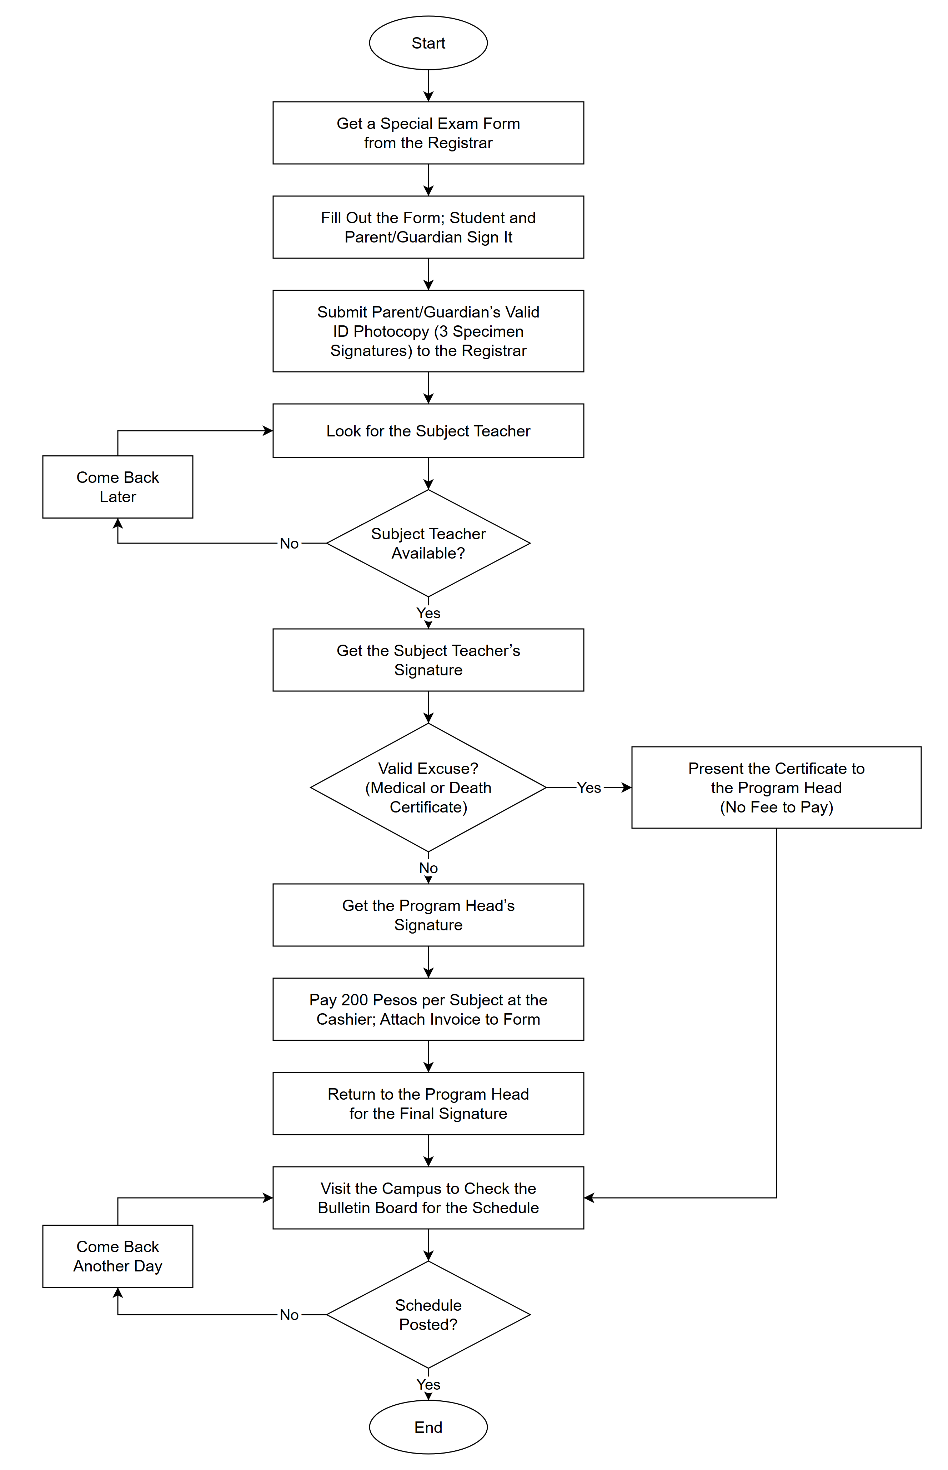
Figure 1.0 Flowchart: Students (Manual Process)
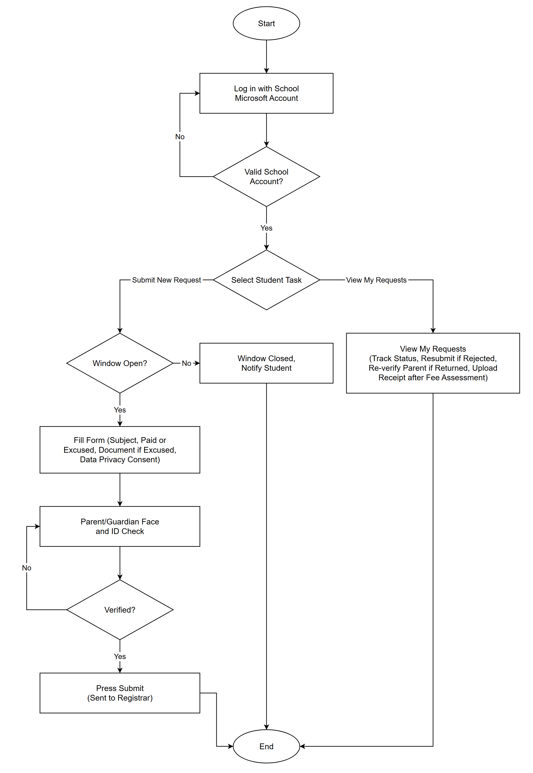
Figure 2.0 Flowchart: Students
Administrator
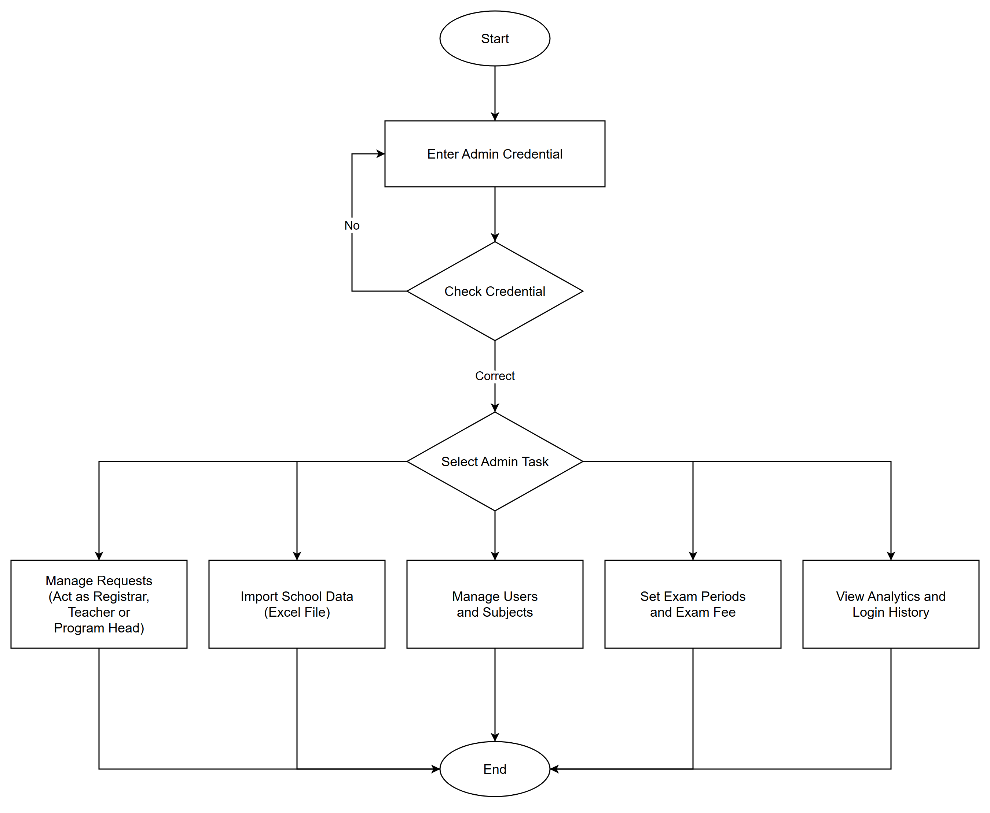
Figure 3.0 Flowchart: Administrator
Program Head
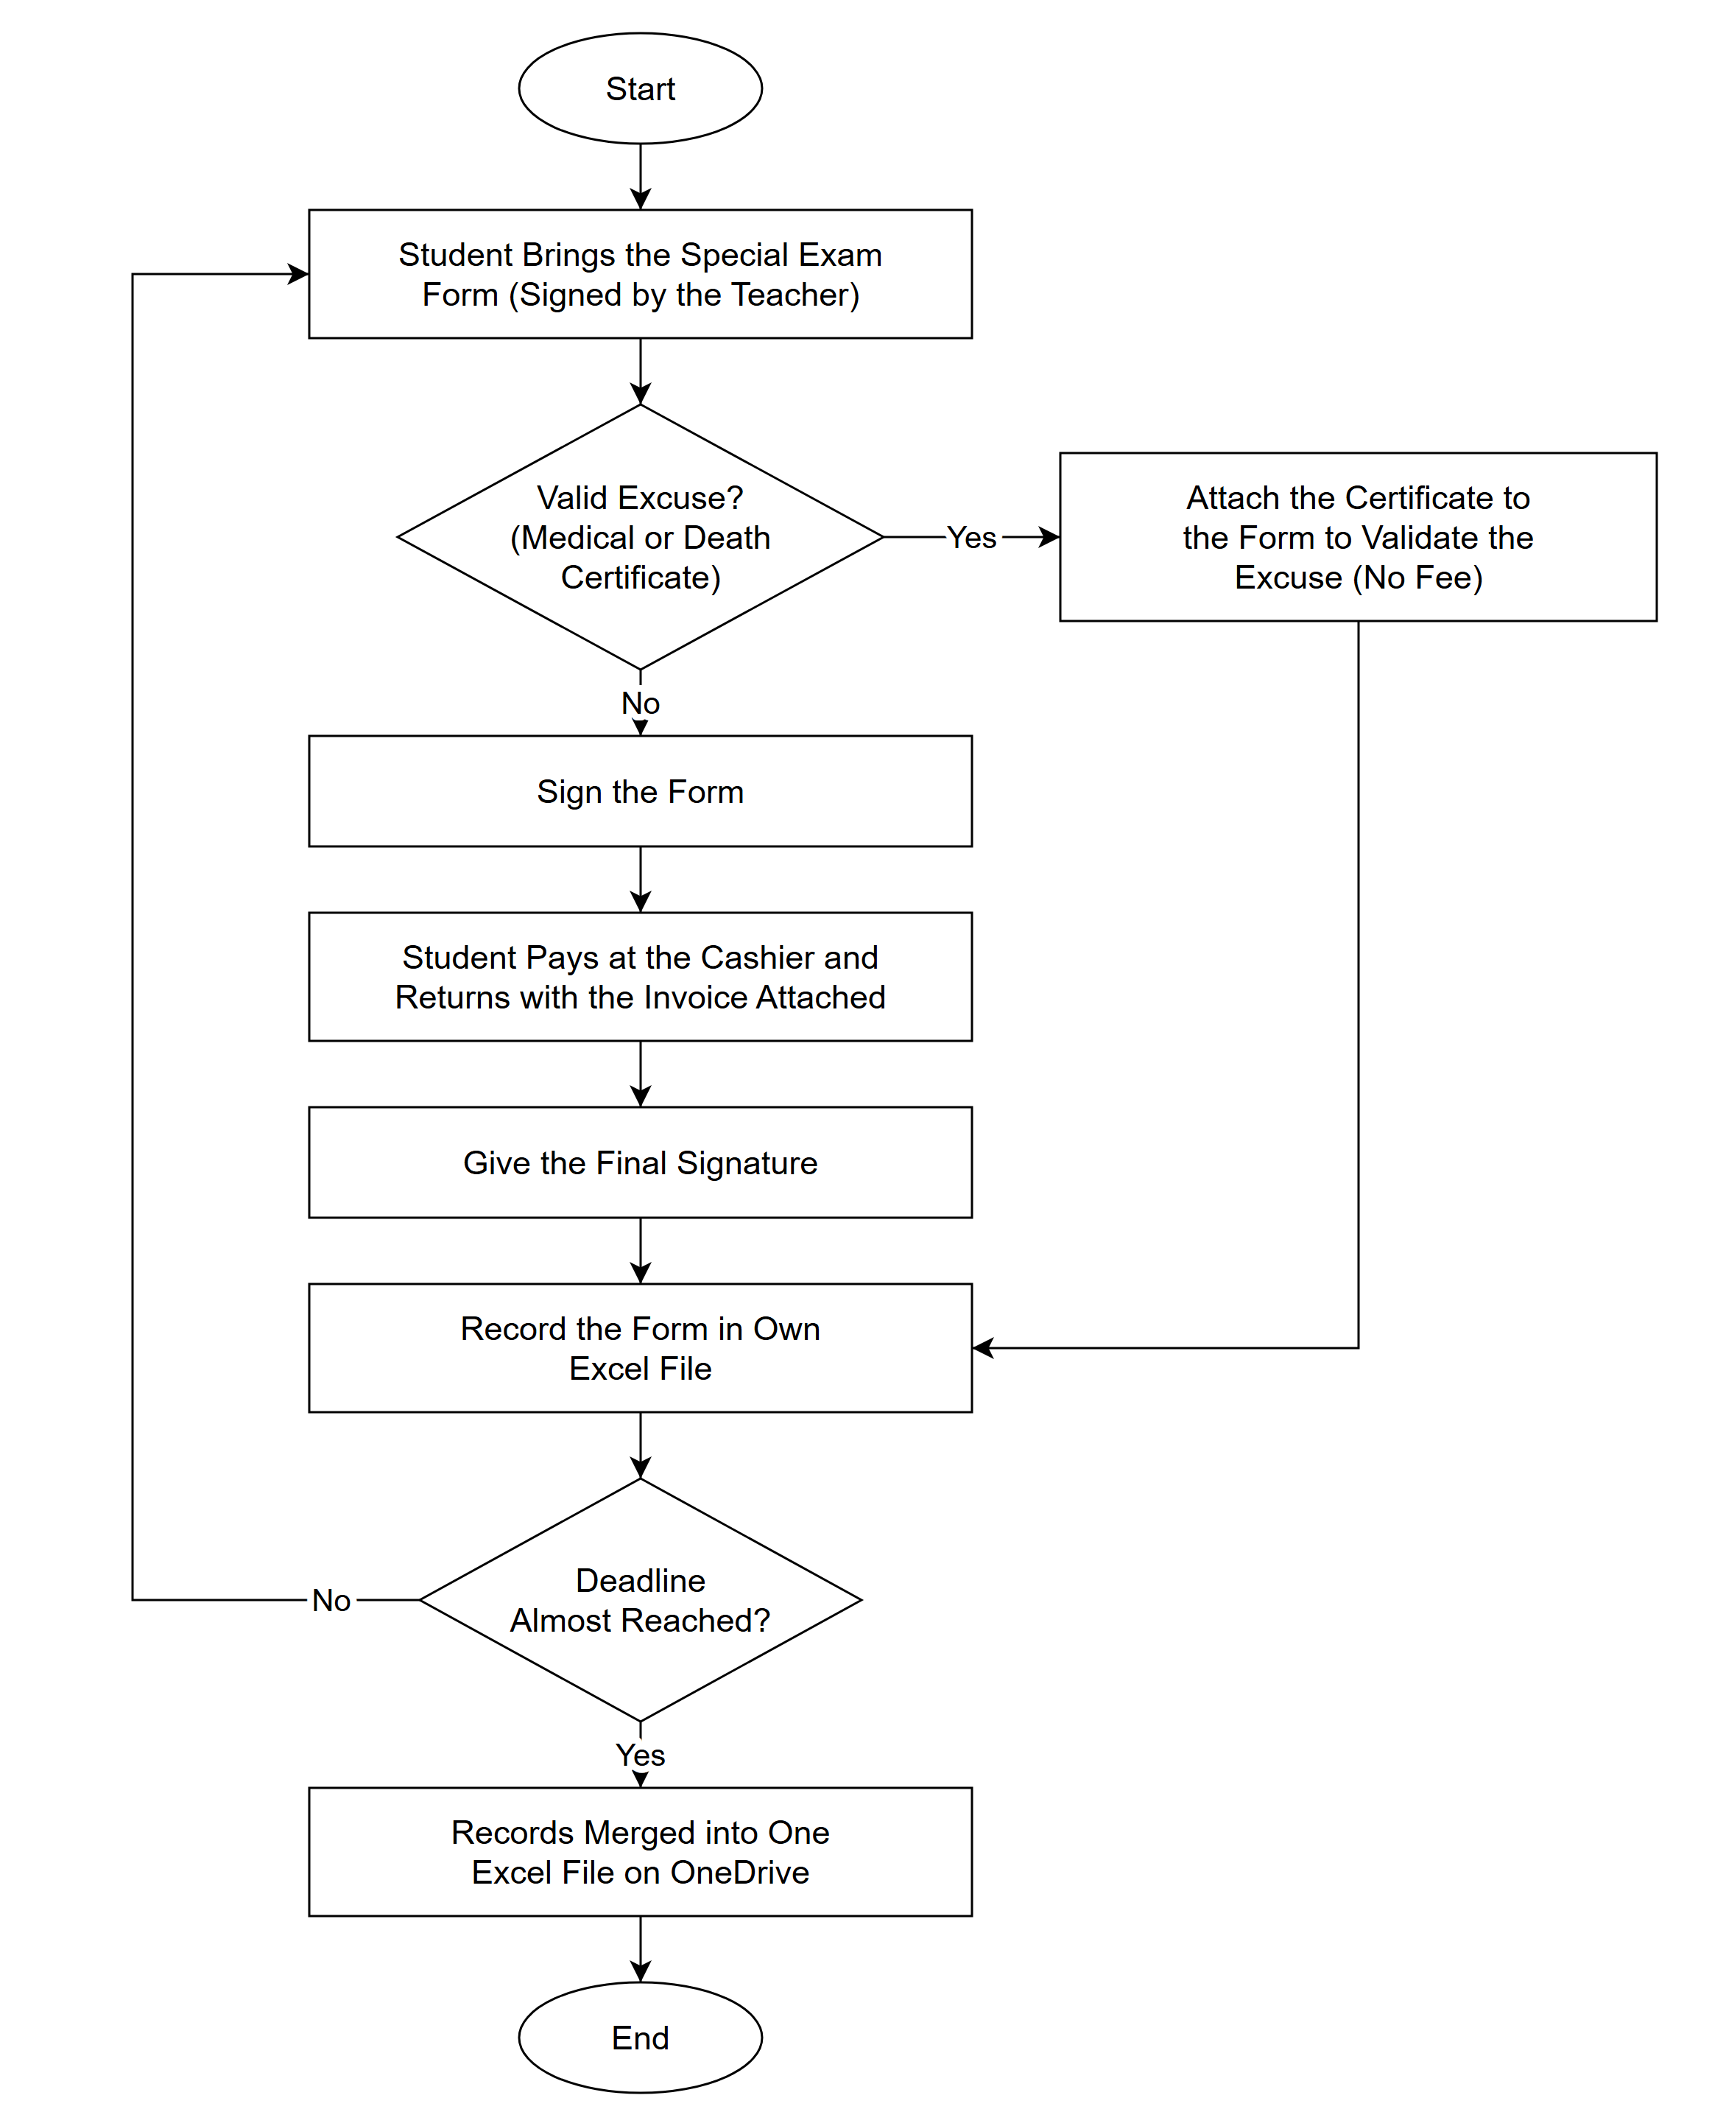
Figure 4.0 Flowchart: Program Head (Manual Process)
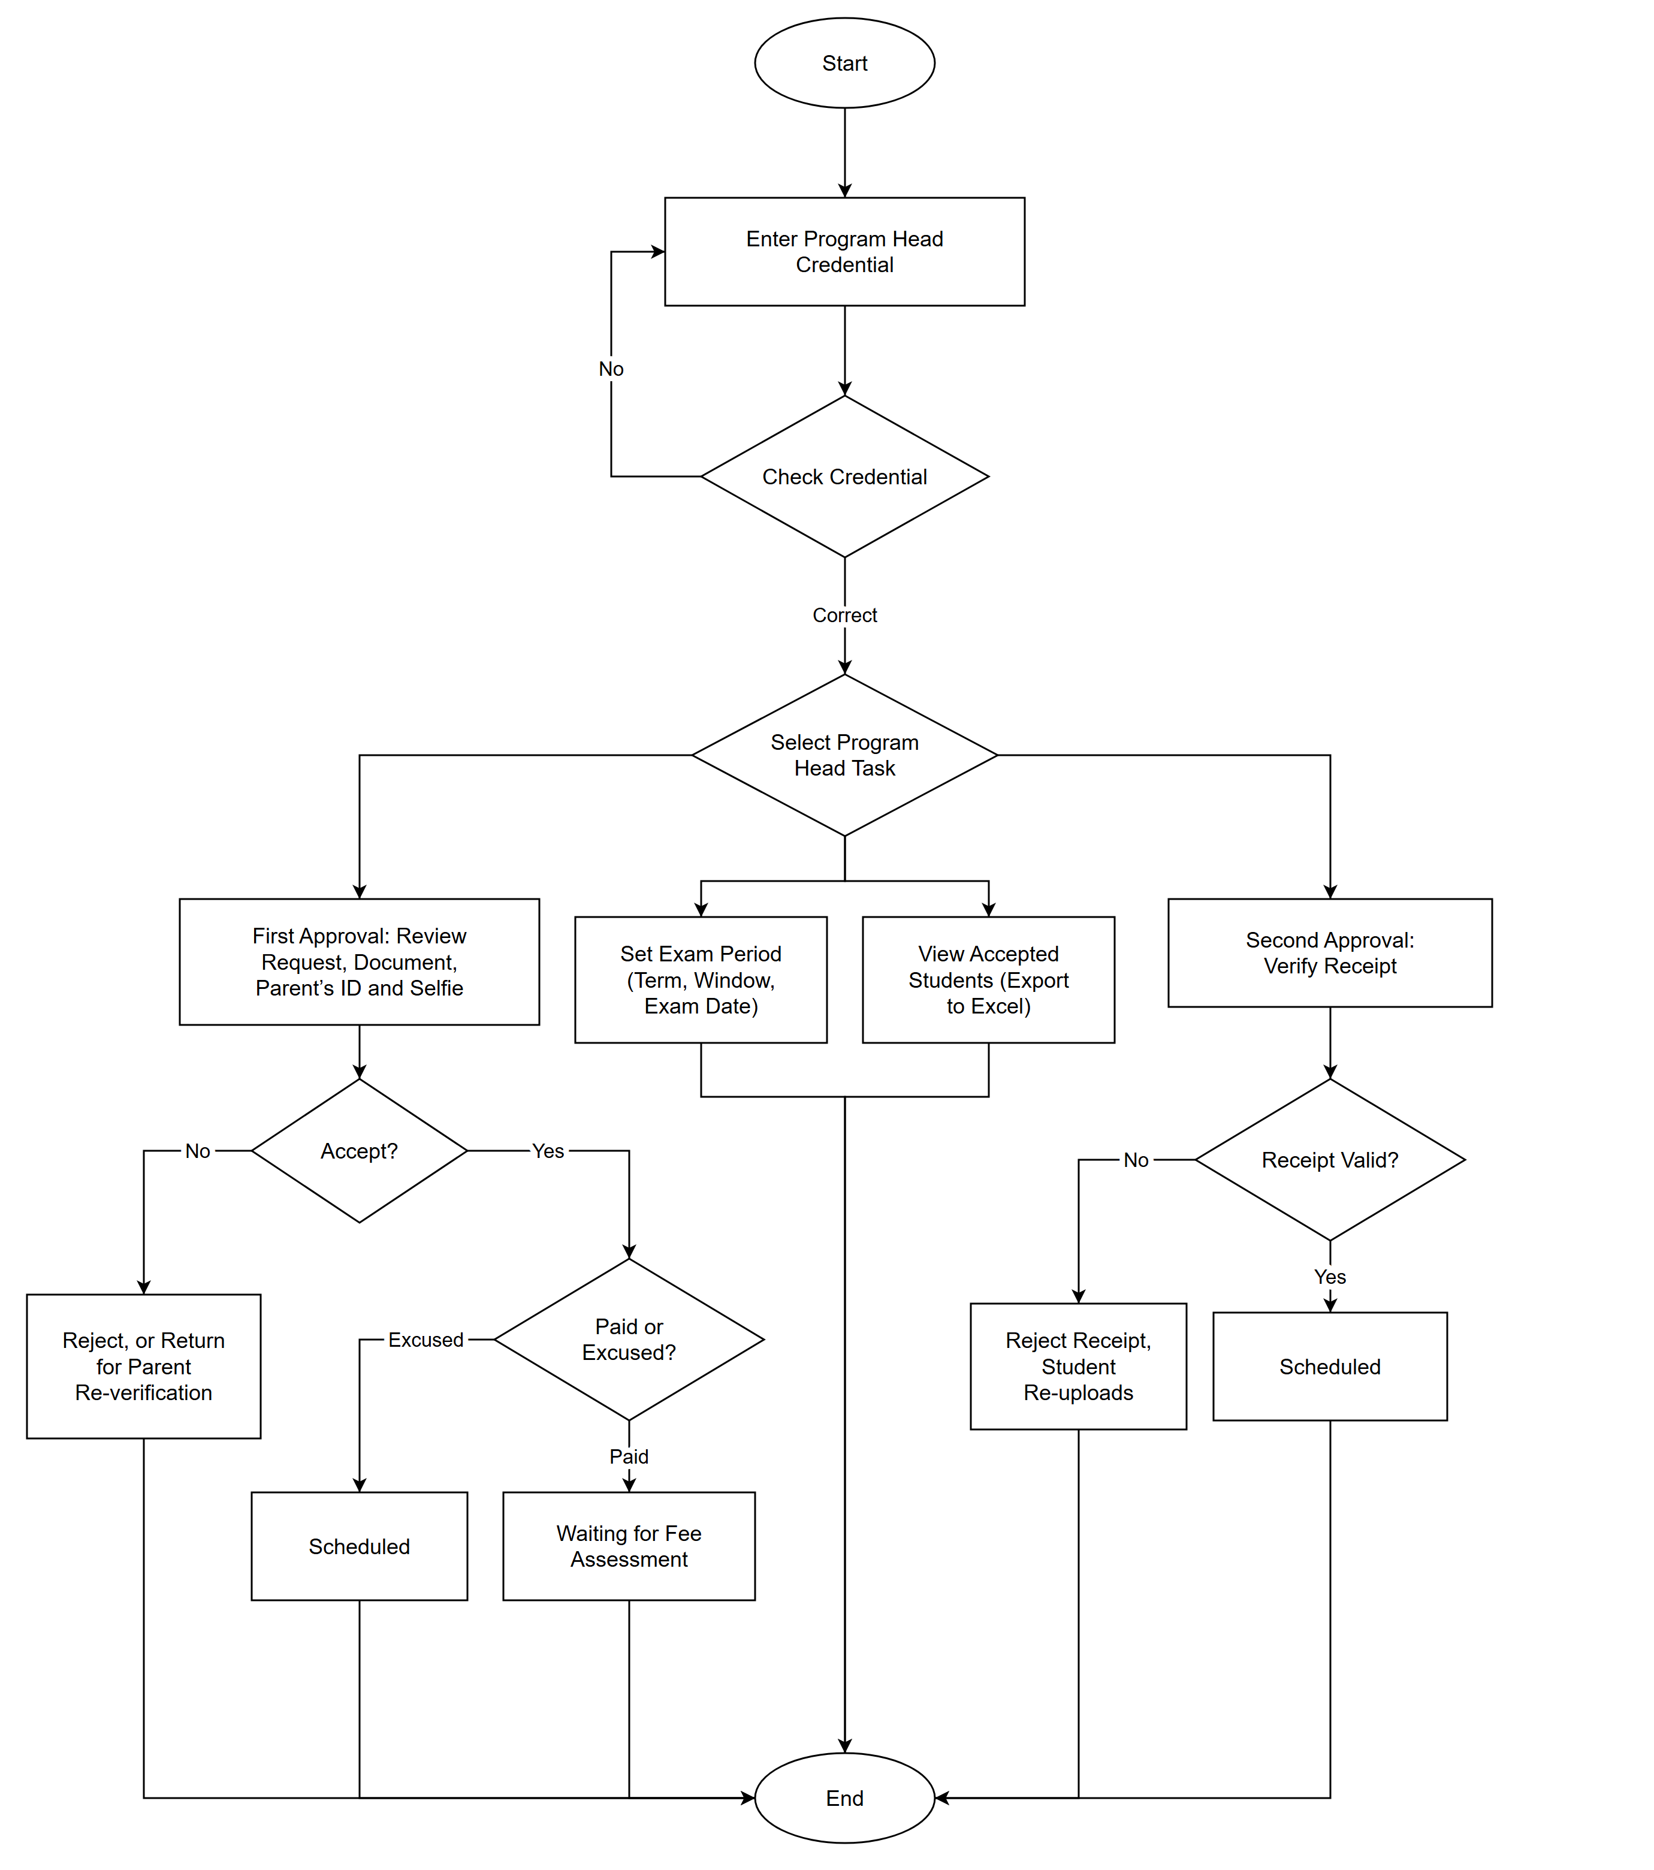
Figure 5.0 Flowchart: Program Head
Registrar
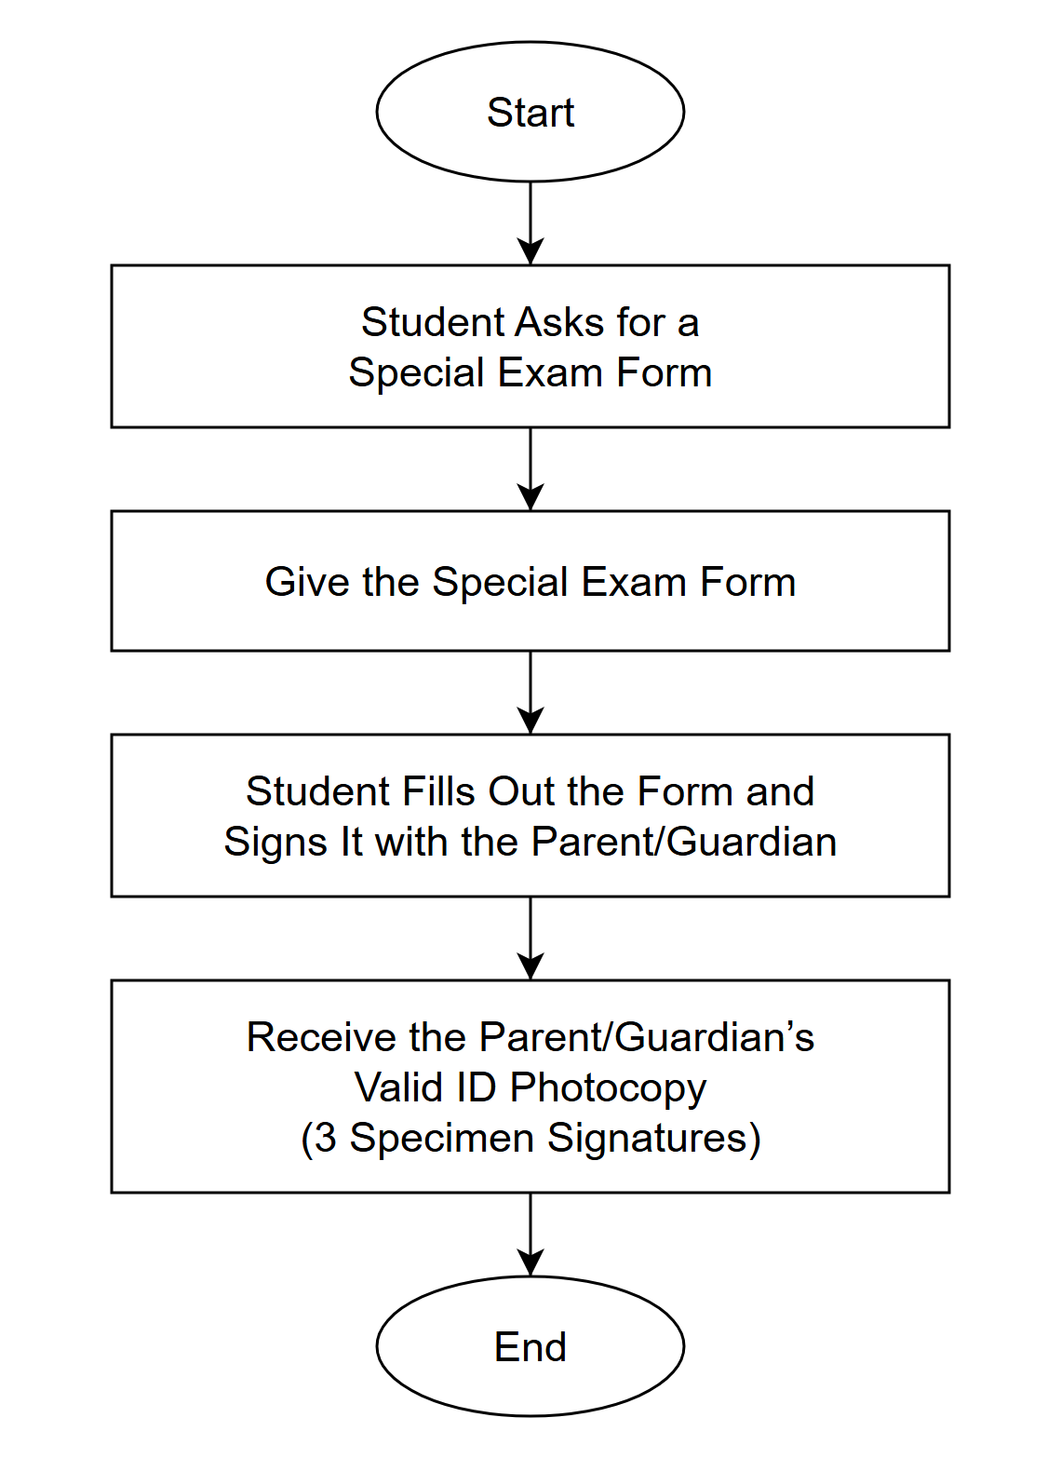
Figure 6.0 Flowchart: Registrar (Manual Process)
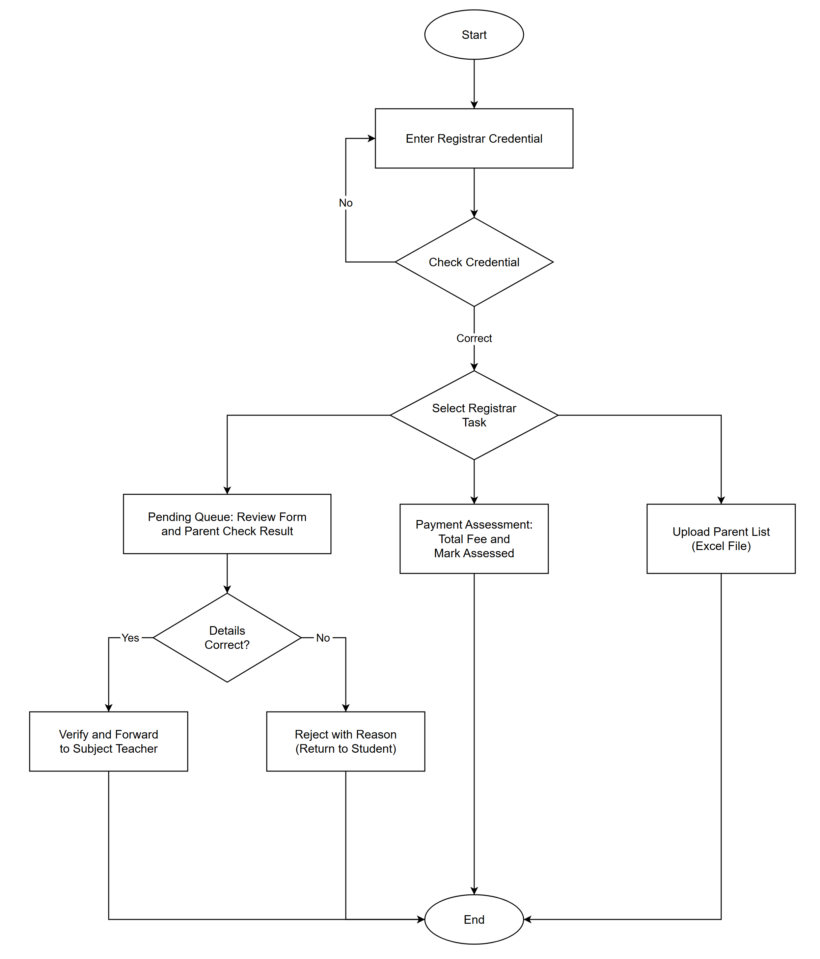
Figure 7.0 Flowchart: Registrar
Subject Teacher
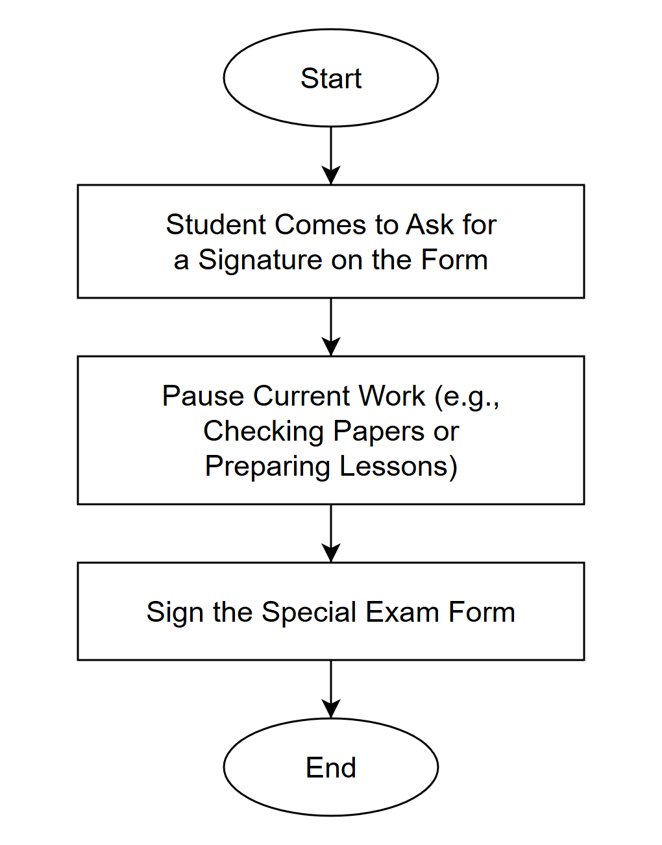
Figure 8.0 Flowchart: Subject Teacher (Manual Process)
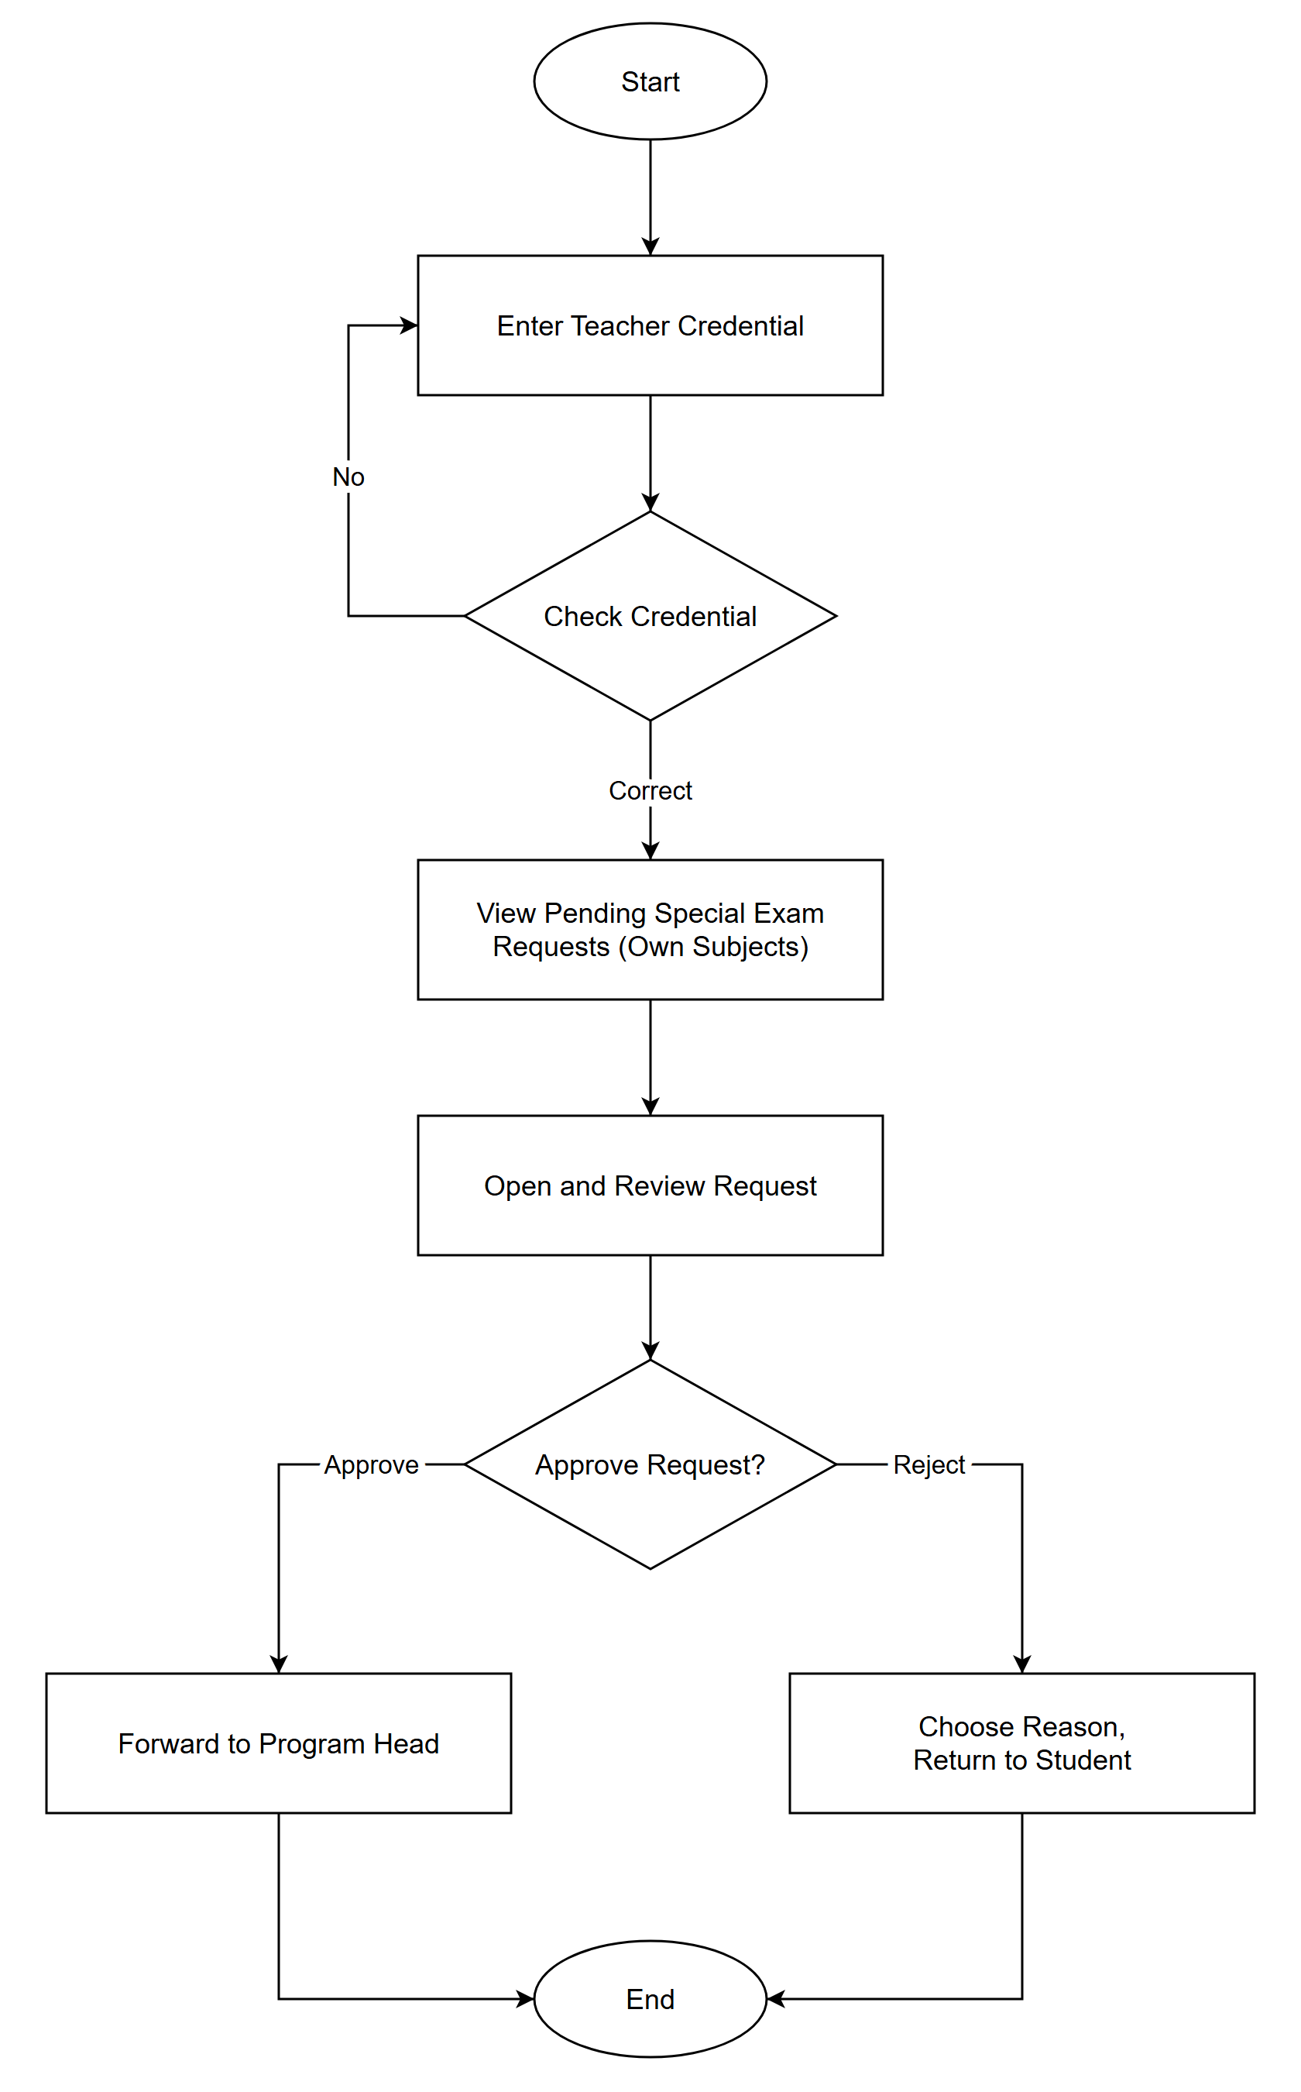
Figure 9.0 Flowchart: Subject Teacher
CONTEXT DIAGRAM
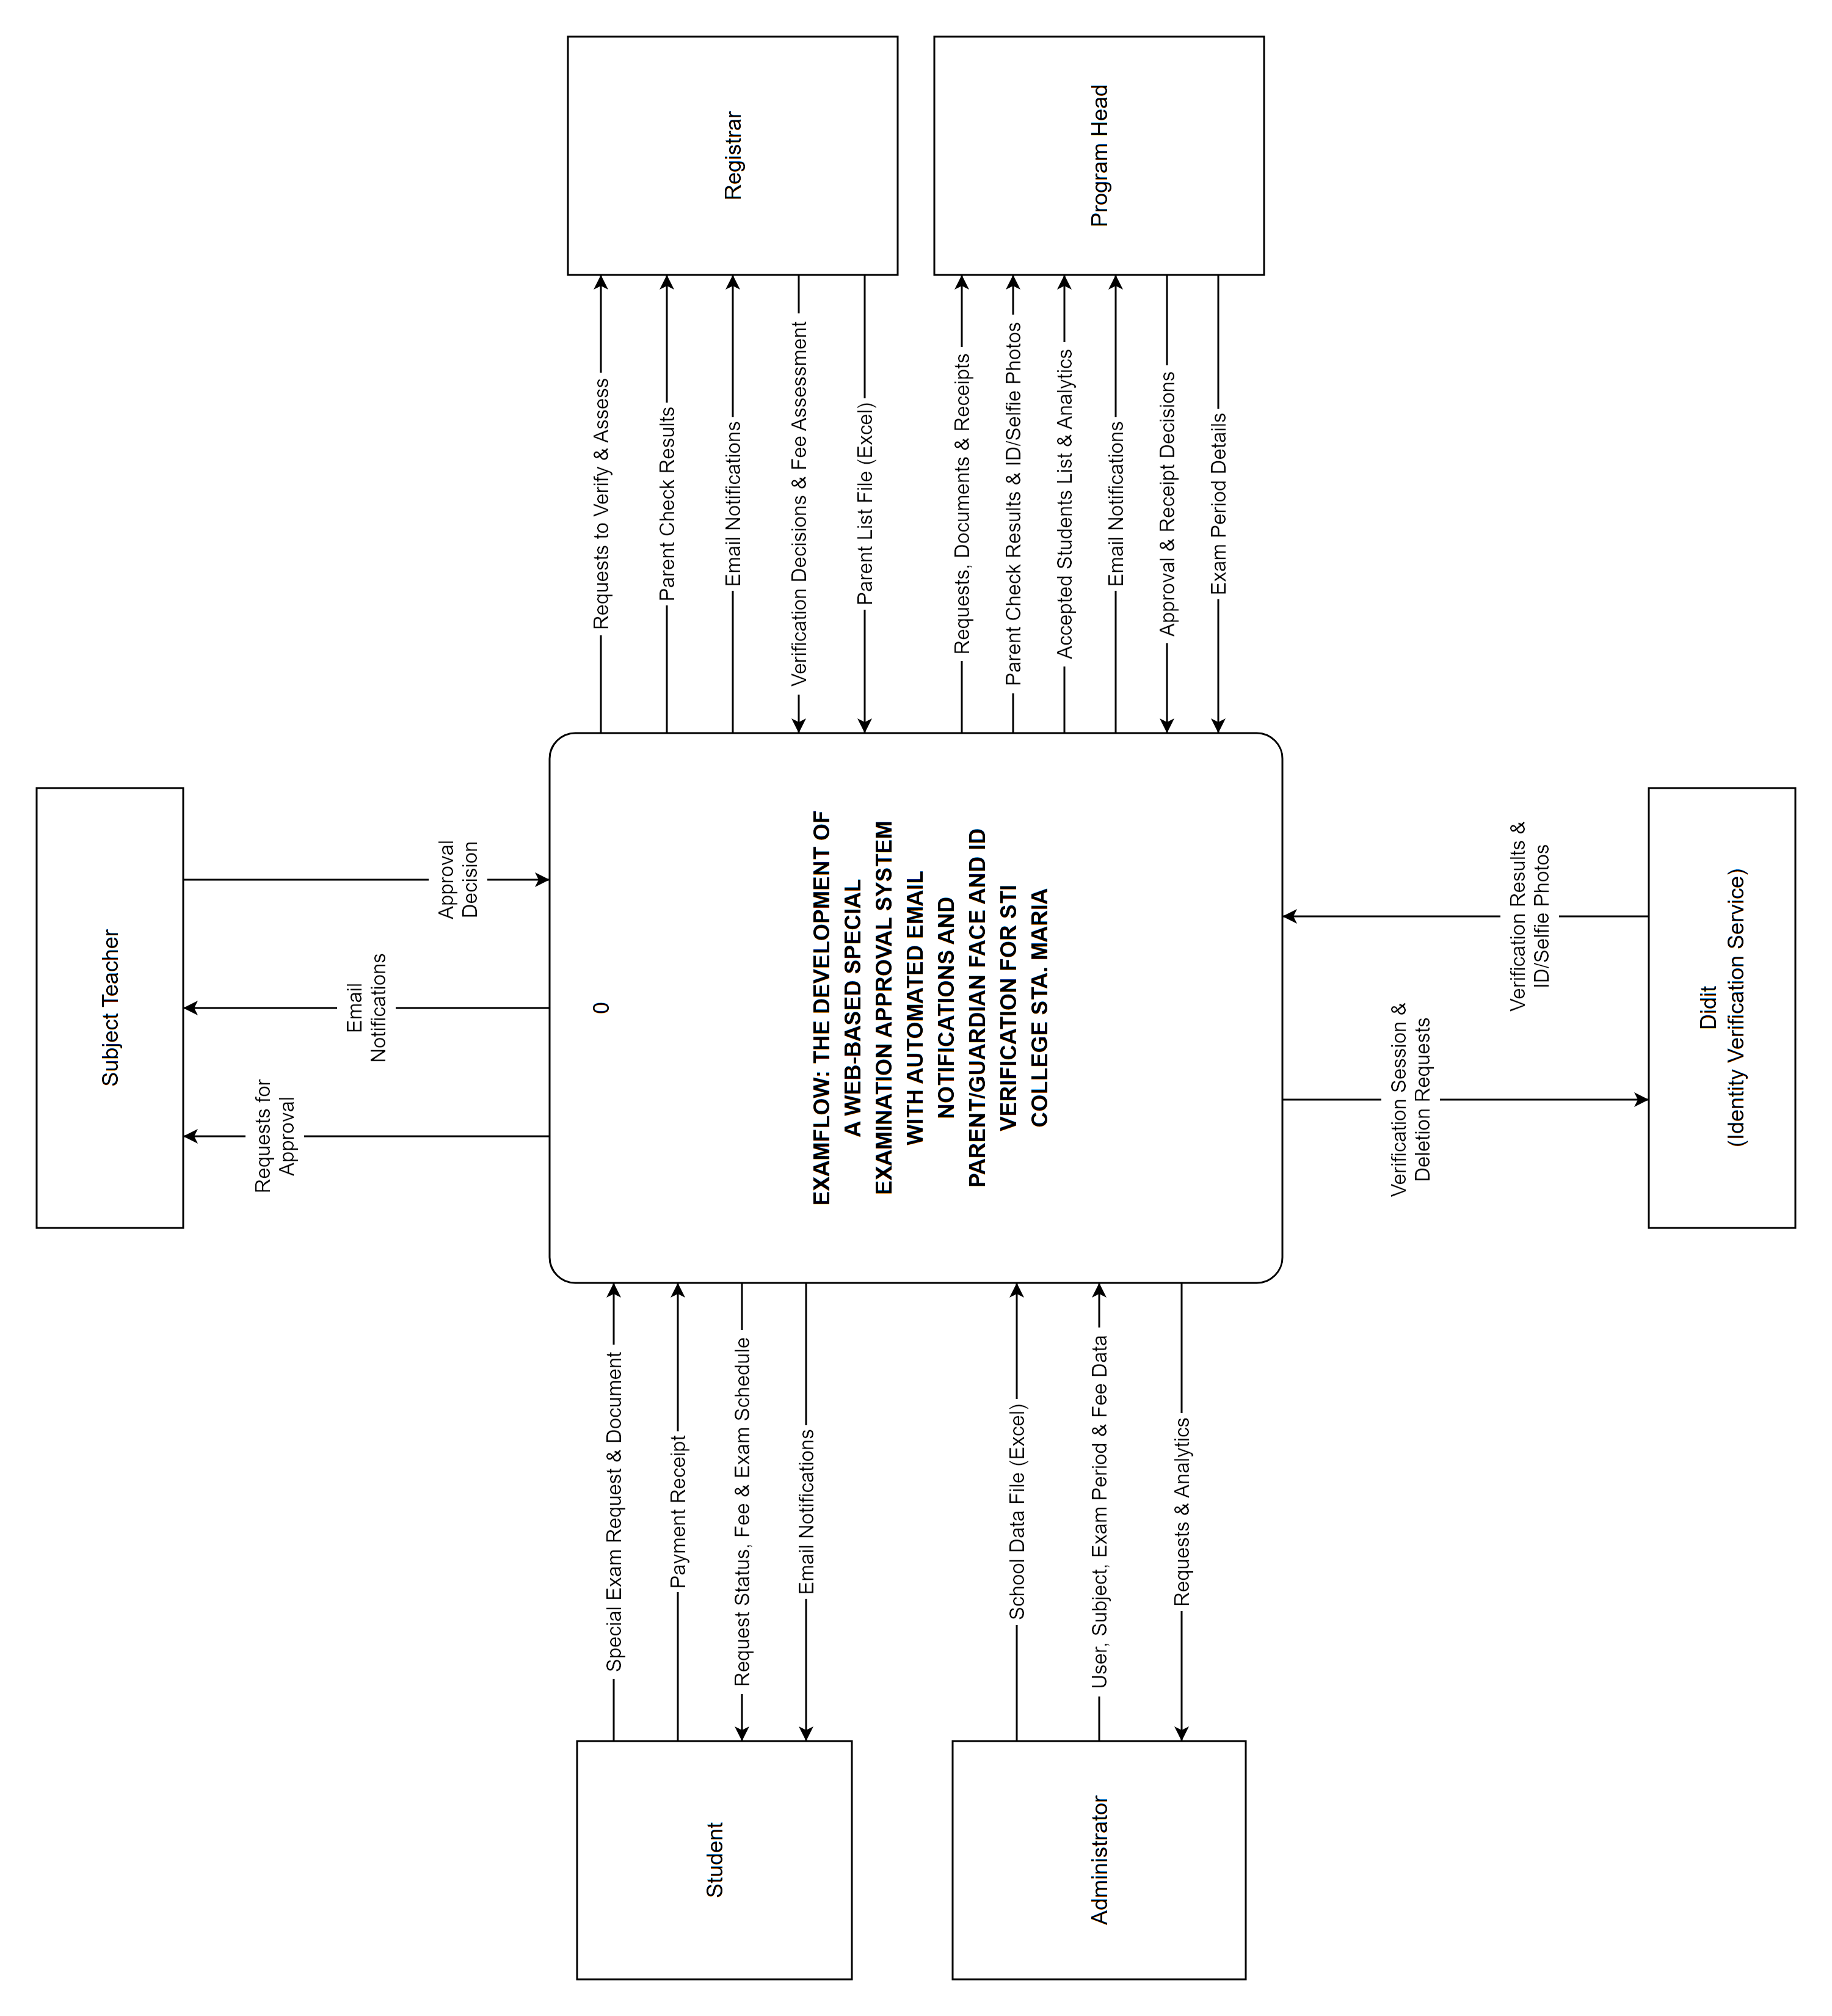
Figure 10.0 Context Diagram
Data Flow Diagram
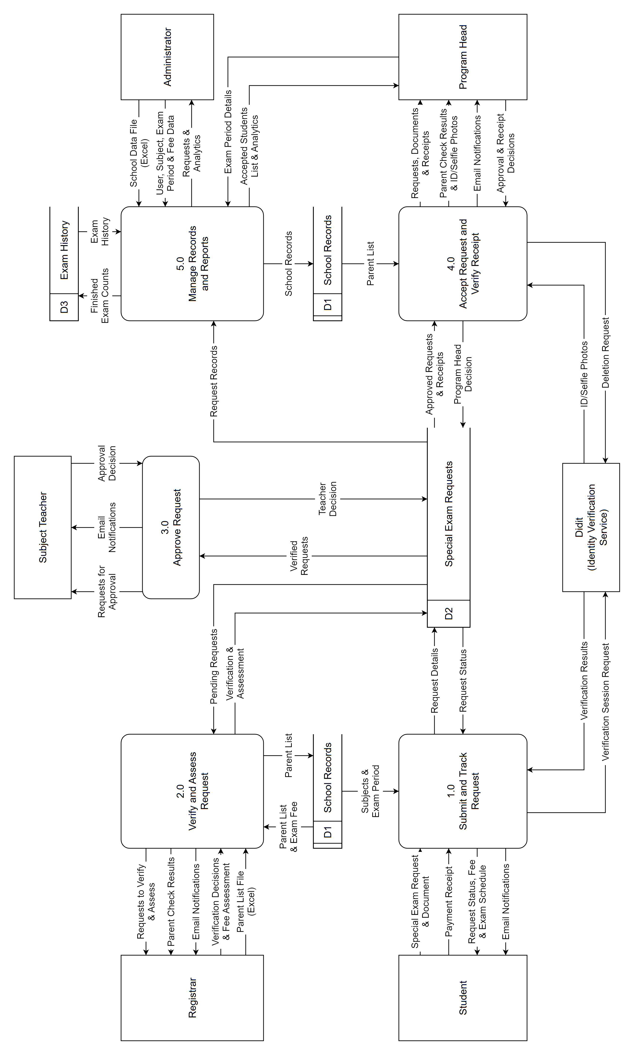
Figure 11.0 Data flow Diagram
ENTITY RELATIONSHIP DIAGRAM
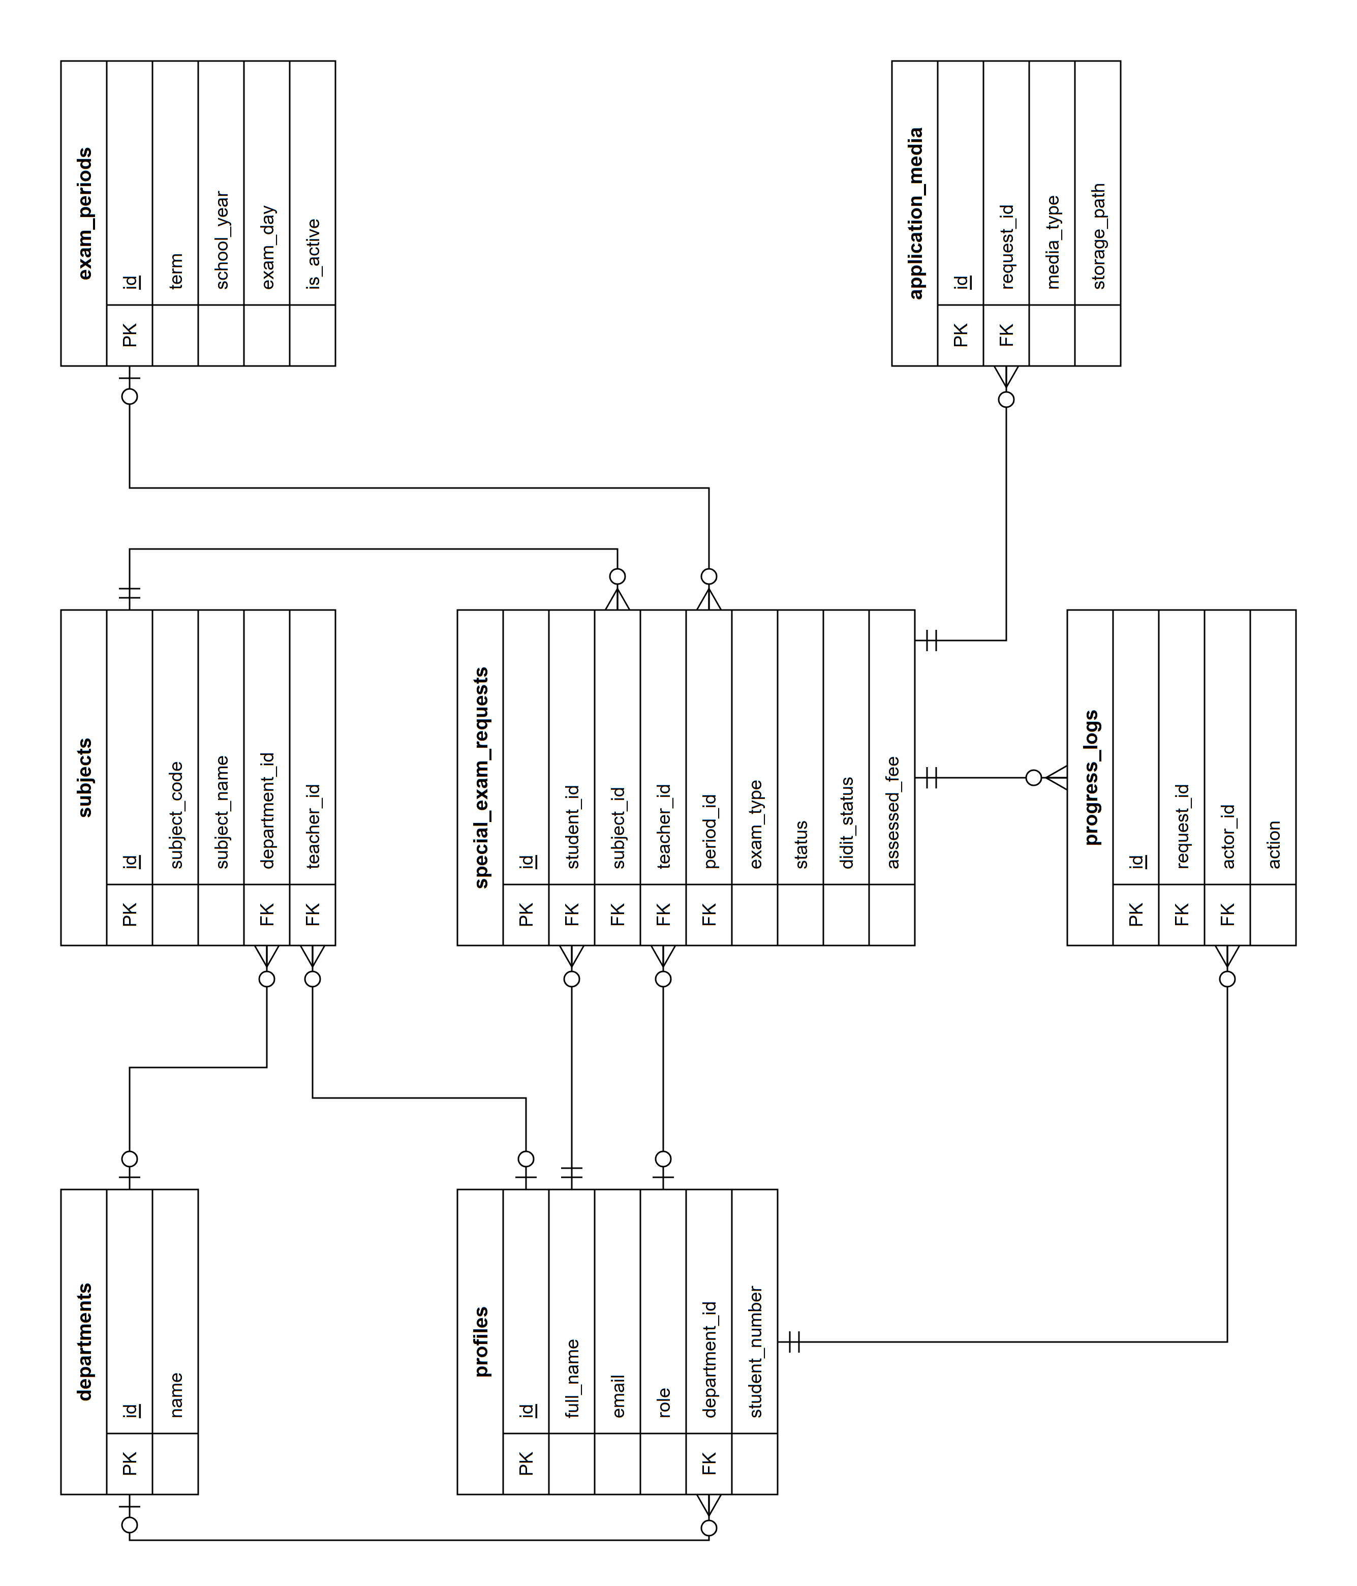
Figure 12.0 Entity Relationship Diagram

APPENDIX C. LETTER TO BENEFICIARY

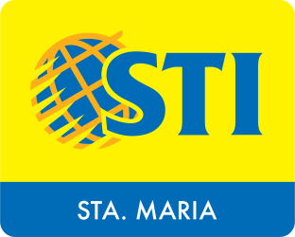

March 24, 2026

Mr. Allan M. Badilla, Jr.
BM Program Head
STI College Sta. Maria
AAA Building, Poblacion, Santa Maria, Bulacan, Philippines

Dear Sir Badilla,

Greetings and Good day!

The students of STI College Sta. Maria, taking up Bachelor of Science in Information Technology, are conducting a research study in developing computerized system.

The students are expected to possess themselves professionally, develop a computer-related programs and its documentation. In this regard, please allow the following students to conduct an interview and survey regarding the processes of your institution:

Aquino, Kurt Vincent
Casano, Justine
Delossantos, R. James
Socorin, John Jeffrey

We hope that you can accommodate our students at your earliest convenience. Rest assured that any documents gathered from your institution in making the project will be kept confidential. Should you have any questions, kindly contact me Delossantos.331286@stamaria.sti.edu.ph at and/or 09707658007. Hoping for your favorable response. Thank you!

Respectfully yours,

Mr. Joshua Galamiton
IT CAPSTONE PROJECT ADVISER

Noted by:

Ms. Ma. Jazmin D. Mateo
ACADEMIC HEAD

March 24, 2026

Ms. Mary Grace Pangilinan
SHS Asst. Principal
STI College Sta. Maria
AAA Building, Poblacion, Santa Maria, Bulacan, Philippines

Dear Ma’am Pangilinan,

Greetings and Good day!

The students of STI College Sta. Maria, taking up Bachelor of Science in Information Technology, are conducting a research study in developing computerized system.

The students are expected to possess themselves professionally, develop a computer-related programs and its documentation. In this regard, please allow the following students to conduct an interview and survey regarding the processes of your institution:

Aquino, Kurt Vincent
Casano, Justine
Delossantos, R. James
Socorin, John Jeffrey

We hope that you can accommodate our students at your earliest convenience. Rest assured that any documents gathered from your institution in making the project will be kept confidential. Should you have any questions, kindly contact me Delossantos.331286@stamaria.sti.edu.ph at and/or 09707658007. Hoping for your favorable response. Thank you!

Respectfully yours,

Mr. Joshua Galamiton
IT CAPSTONE PROJECT ADVISER

Noted by:

Ms. Ma. Jazmin D. Mateo
ACADEMIC HEAD

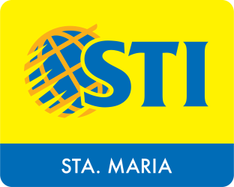

March 19, 2026

Lara Camille Vergara
ICT Head Department
STI College Sta. Maria
STI Building, Poblacion, Sta. Maria, 3022 Bulacan

Dear MA’AM,

Greetings and Good day!

The students of STI College Sta. Maria, taking up Bachelor of Science in Information Technology, are conducting a research study in developing computerized system.

The students are expected to possess themselves professionally, develop a computer-related programs and its documentation. In this regard, please allow the following students to conduct an interview and survey regarding the processes of your institution:

Aquino, Kurt Vincent
Casano, Justine
Delossantos, R. James
Socorin, John Jeffrey

We hope that you can accommodate our students at your earliest convenience. Rest assured that any documents gathered from your institution in making the project will be kept confidential. Should you have any questions, kindly contact me Delossantos.331286@stamaria.sti.edu.ph at and/or 09707658007. Hoping for your favorable response. Thank you!

Respectfully yours,

Mr. Joshua Galamiton
IT CAPSTONE PROJECT ADVISER

Noted by:

Ms. Ma. Jazmin D. Mateo
ACADEMIC HEAD

March 24, 2026

Registrar
STI College Sta.Maria
AAA Building, Poblacion, Santa Maria, Bulacan, Philippines

Dear SIR/MA’AM,

Greetings and Good day!

The students of STI College Sta. Maria, taking up Bachelor of Science in Information Technology, are conducting a research study in developing computerized system.

The students are expected to possess themselves professionally, develop a computer-related programs and its documentation. In this regard, please allow the following students to conduct an interview and survey regarding the processes of your institution:

We hope that you can accommodate our students at your earliest convenience. Rest assured that any documents gathered from your institution in making the project will be kept confidential. Should you have any questions, kindly contact me Delossantos.331286@stamaria.sti.edu.ph at and/or Casano.340503@stamaria.sti.edu.ph
Hoping for your favorable response. Thank you!

Respectfully yours,

Mr. Joshua Galamiton
IT CAPSTONE PROJECT ADVISER

Noted by:

Ms. Ma. Jazmin D. Mateo
ACADEMIC HEAD

APPENDIX D. PERSONAL TECHNICAL VITAE

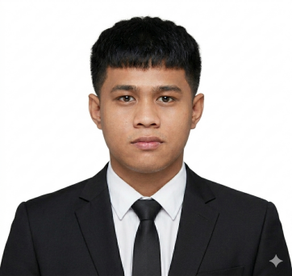
Curriculum Vitae of
Justine C Casano
Blk 76 lot 14 Las Palmas subd. Cay Pombo,
Sta Maria, Bulacan
Casano.340503@stamaria.sti.edu.ph
+63 9943319300

Educational Background
Level | Inclusive Dates | Name of School/Institution
Tertiary | August 2023 - Present | STI College Santa Maria
Vocational/Technical | August 2021 – July 2023 | Mystical Rose School of Bulacan Inc
High School | June 17 – July 2021 | FFHNAS – Cay Pombo Annes
Elementary | June 2011 – April 2017 | Cay Pombo Elementary School

Skills
Skills | Level of Competency | Date Acquired
System Integration & Architecture | Basic | September 2025
Java Fundementals | Basic | September 2024
System Administration and Maintenance | Basic | September 2024

Trainings, Seminar, Or Workshops Attended
Inclusive Dates | Title of Training, Seminar, or Workshop
April 2026 | When AI, learns to talk: Understanding NPL & Cyber Ethics and Responsible Use of Technology
February 2026 | Research Methodology in ICT: From Concept to Implementation

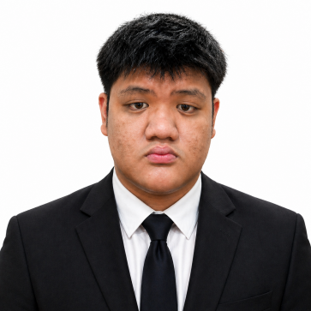
Curriculum Vitae of
John Jeffrey C. Socorin
1247 Yakal street Sta. Clara Sta Maria Bulacan
Socorin.332598@stamaria.sti.edu.ph
+63 969 645 3284

Educational Background
Level | Inclusive Dates | Name of School/Institution
Tertiary | August 2023 - Present | STI College Santa Maria
Vocational/Technical | August 2021 – July 2023 | Grace of Shekinah School
High School | June 17 – July 2021 | Grace of Shekinah School
Elementary | June 2011 – April 2017 | Grace of Shekinah School

Skills
Skills | Level of Competency | Date Acquired
System Integration & Architecture | Basic | September 2025
Java Fundementals | Basic | September 2024
System Administration and Maintenance | Basic | September 2024

Trainings, Seminar, Or Workshops Attended
Inclusive Dates | Title of Training, Seminar, or Workshop
April 2026 | When AI, learns to talk: Understanding NPL & Cyber Ethics and Responsible Use of Technology
February 2026 | Research Methodology in ICT: From Concept to Implementation

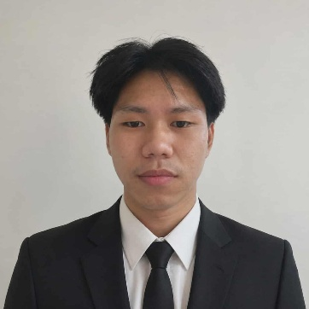
Curriculum Vitae of
R. James M. Delos Santos
Ilang-Ilang st. Sta Rosa 2,
Sta Maria, Bulacan
Delossantos.331286@stamaria.sti.edu.ph
+63 09707658007

Educational Background
Level | Inclusive Dates | Name of School/Institution
Tertiary | August 2023 - Present | STI College Santa Maria
Vocational/Technical | August 2021 – July 2023 | Saint Amatiel Technological Institute
High School | June 17 – July 2021 | Prenza National Highschool
Elementary | June 2011 – April 2017 | Patubig Elementary Scohol

Skills
Skills | Level of Competency | Date Acquired
System Integration & Architecture | Basic | September 2025
Java Fundementals | Basic | September 2024
System Administration and Maintenance | Basic | September 2024

Trainings, Seminar, Or Workshops Attended
Inclusive Dates | Title of Training, Seminar, or Workshop
April 2026 | When AI, learns to talk: Understanding NPL & Cyber Ethics and Responsible Use of Technology
February 2026 | Research Methodology in ICT: From Concept to Implementation

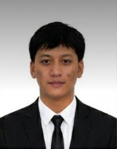
Curriculum Vitae of
Kurt V. Aquino
Blk 76 lot 6 Las Palmas subd. Cay Pombo,
Sta Maria, Bulacan
Aquini.359906@stamaria.sti.edu.ph
+63 9563319569
Educational Background
Level | Inclusive Dates | Name of School/Institution
Tertiary | August 2023 - Present | STI College Santa Maria
Vocational/Technical | August 2021 – July 2023 | Mystical Rose School of Bulacan Inc
High School | June 17 – July 2021 | Mystical Rose of Bulacan
Elementary | June 2011 – April 2017 | John Wesley Christian School

Skills
Skills | Level of Competency | Date Acquired
System Integration & Architecture | Basic | September 2025
Java Fundementals | Basic | September 2024
System Administration and Maintenance | Basic | September 2024

Trainings, Seminar, Or Workshops Attended
Inclusive Dates | Title of Training, Seminar, or Workshop
April 2026 | When AI, learns to talk: Understanding NPL & Cyber Ethics and Responsible Use of Technology
February 2026 | Research Methodology in ICT: From Concept to Implementation

